English worksheet

Television and advertising

Full Name: …………………………………………………………..

|  |  |
| --- | --- |
| antorcha liceo | **Liceo República Argentina**  Coyhaique  English Worksheets  Teacher Dircia Ampuero |

|  |  |  |  |
| --- | --- | --- | --- |
| **ASIGNATURA** | Inglés | **CURSO** | 4º medio |
| **PROFESOR** | Dircia Ampuero Catalán | **PERÍODO DE TRABAJO** | 5 de Agosto al 19 de Agosto 2020. |

**Objective**: Revisar e introducir vocabulario, sobre la vida real, los reality shows y la publicidad a través de actividades de organización de información, comprensión, inferencia, selección y aplicación de vocabulario.

**Instruction:** Complete the sentences in the worksheet and then send me an email, with the answers in color red or answer in your copybook and send me a photo,

[ampuero.catalan.dircia@gmail.com](mailto:ampuero.catalan.dircia@gmail.com)

1. **Look at the following pictures and answer the questions.**



1. Among all the TV programs available, what is your favourite one? Please explain why.
2. Have you ever seen a reality show? If so, did you like it? Why/why not?

|  |  |
| --- | --- |
| **A** | **B** |
| 1. Audience 2. Showcase 3. Advertising 4. Team 5. Eliminate | ____Exhibit, display  ____Group, company, contestants  ____ Remove, vote off  ____ Spectators, viewers  ____ Commercial, message |

1. **Most TV programs include certain features depending on their format. Match the words to their synonyms:**

|  |
| --- |
| Voted off – objective – talented – audience - perform |

1. **Look the following sentences about reality TV, complete them with the vocabulary from the box, and then match to the pictures below:**
2. I think you are such a **__________** artist
3. The latest celebrity to be **__________** this year's Master Chef has been revealed.
4. The winning **___________** will receive a cash prize
5. My main __________ is to win this competition and receive a cash prize
6. I always **___________** the same show of my dancing
7. The concert attracted a large **__________** who clapped and cheered

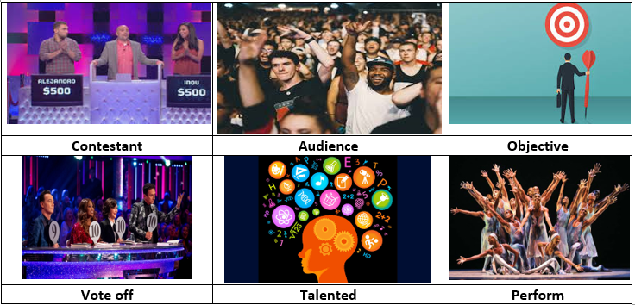

1. **Underline the best option in each sentence.**
2. One of my favourite artists of all times is Andy Warhol. He was such a **talented/showcase** artist.
3. I think that the main **objective/perform** of art is to emancipate the soul.
4. All the **audience/contestants** in the show were vote off last week.
5. For the following challenge you need to work in **teams/contestants.**
6. TV shows are one of the best opportunities to show **advertising/commercial.**
7. **listed below are few key words for talking about reality shows. One word in each group does not belong. Which one? Explain why.**
8. Eliminate – Vote off- Join
9. Showcase- perform – audience
10. Objective- talented- aim
11. __________________
12. __________________
13. __________________
14. **Imagine that you and your classmates are in a reality show about your school life, and then answer the questions below. Remember, be creative and respectful!**
15. Who would be the audience of this reality show?

_______________________________________________

1. Who would be the first eliminated, and why?

_______________________________________________

1. Who would be considered among the most talented in the group?

_______________________________________________

1. Who would you like to join you in a team performance?

_______________________________________________

1. What would you showcase?

_________________________________________________