|  |  |
| --- | --- |
| antorcha liceo | **Liceo República Argentina**  Coyhaique  English Worksheets  Teacher Dircia Ampuero |

English worksheet

Globalization and Culture

2º medio

Full Name: …………………………………… Grade: ………………………

**Objective**: identify relevant and specific information.

Recognize the most important factors that are part of your identity.

describe the advantages / disadvantages of a technological advance.

**Instruction:**

Complete the sentences in the worksheet and then send me an email, with the answers in color red or answer in your copybook and send me a photo,

ampuero.catalan.dircia@gmail.com

**Delivery date, August, Tuesday 4th 2020.**

1. Have a look at the pictures (1 – 4) and write the name of some of the aspects that represent a group’s culture.

TRADITIONAL DANCE FLAGS LANGUAGES CELEBRATIONS

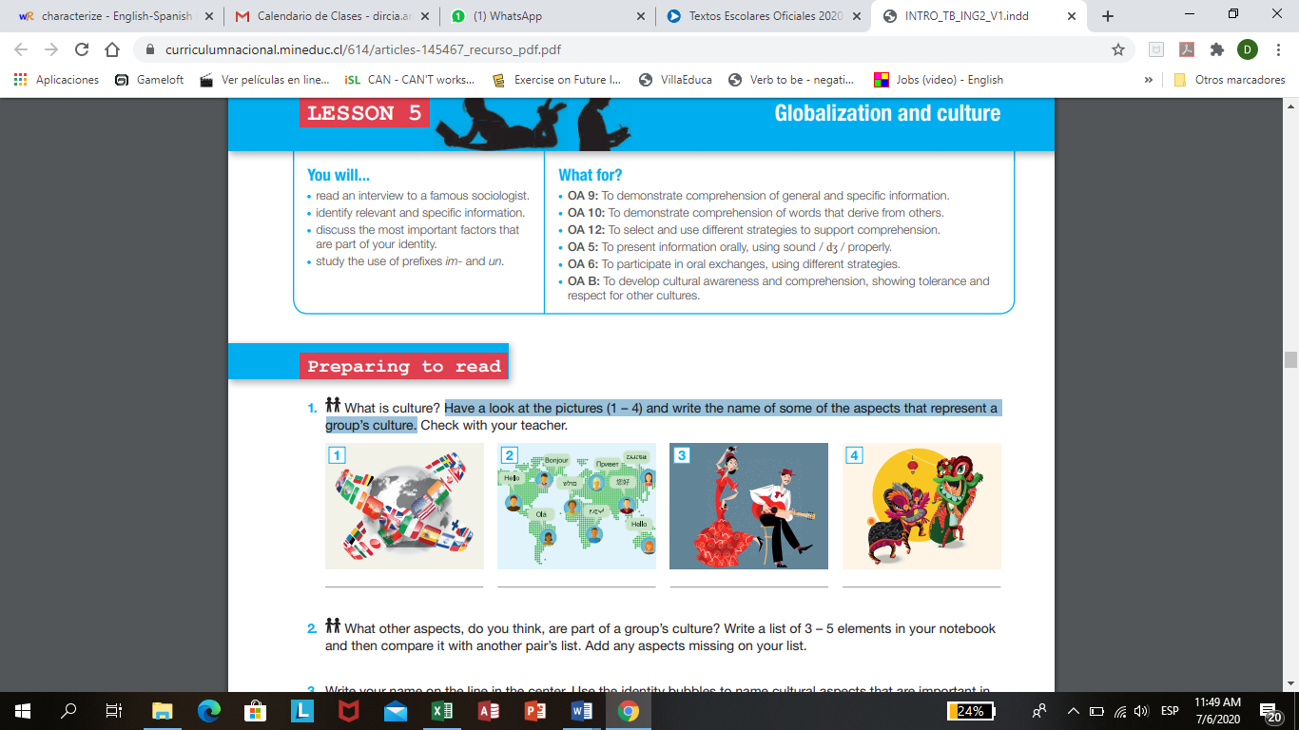

1. Write your name on the line in the center. Use the identity bubbles to name cultural aspects that are important in defining who you are.
2. According to your country write food, language and typical music of your country.

|  |  |
| --- | --- |
| TYPICAL FOOD |  |
| LANGUAGE YOU SPEAK |  |
| TYPICAL CEREMONIES |  |
| TYPICAL DANCE |  |

***Technology and its effects***

1. 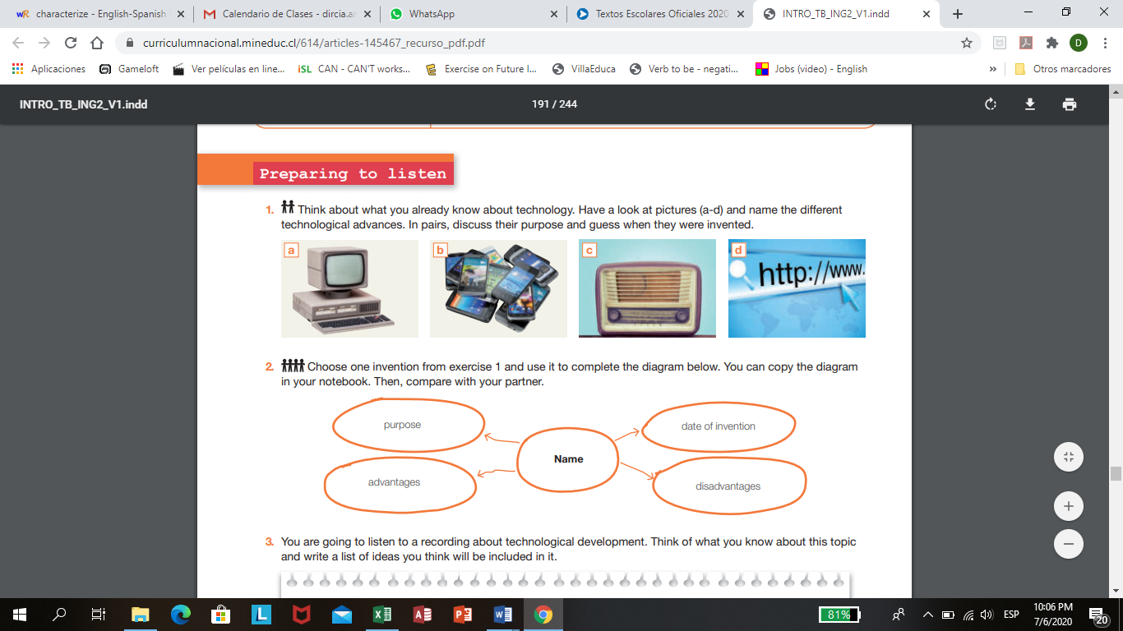Have a look at pictures (a-d) and name the different technological advances.

…………………….. …………………….... ……………………… ………………………...

Choose one invention from exercise 1 and use it to complete the diagram below. Use the internet to find the information required.

Name

Date of invention

advantages

Purpose

disadvantages

1. **In your opinion which of the following statements are true?**
2. …………… The use of the internet and social networks can become an addiction.
3. …………… The internet is taking the place of sports and games.
4. …………… Social networks may lead to antisocial behavior.
5. …………… Teens spend more time in cyberspace than in the real world.
6. 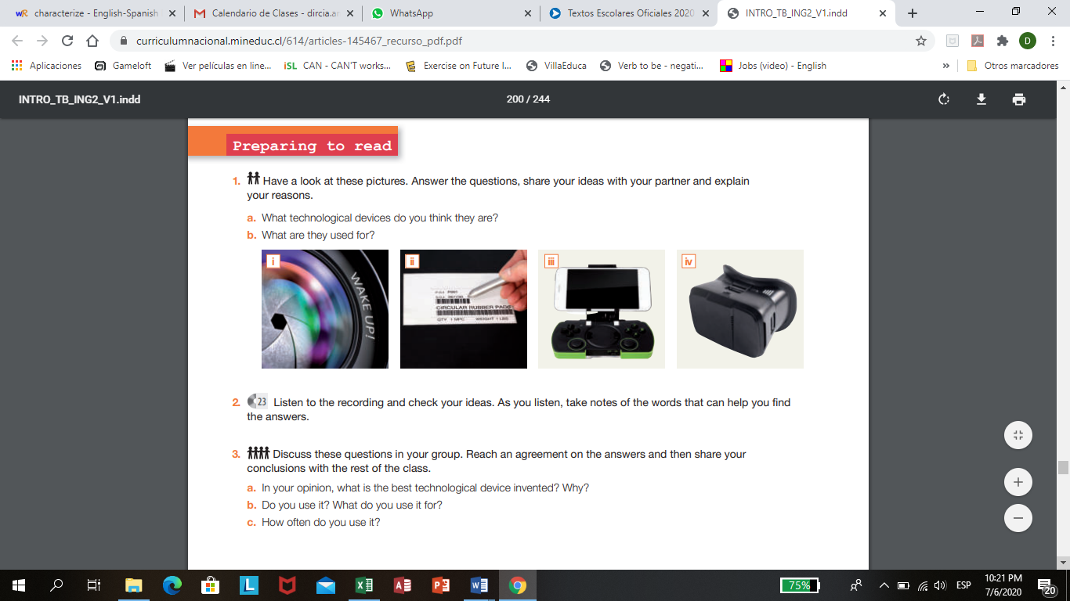**Have a look at these pictures. Answer the questions.**
7. What technological devices do you think they are? Write their names.

i……………………………………. ii…………………………………………

iii…………………………………… iv………………………………………...

1. What are they used for?

i…………………………………………. ii………………………………………….

iii………………………………………… iv…………………………………………

In your opinion what is the best technological device invented? (anyone)

……………………………………………………………….

Do you use it?..................................... What do you use it for?.................................

How often do you use it? ………………………………………………………….

1. Read the text on the user´s manual carefully.

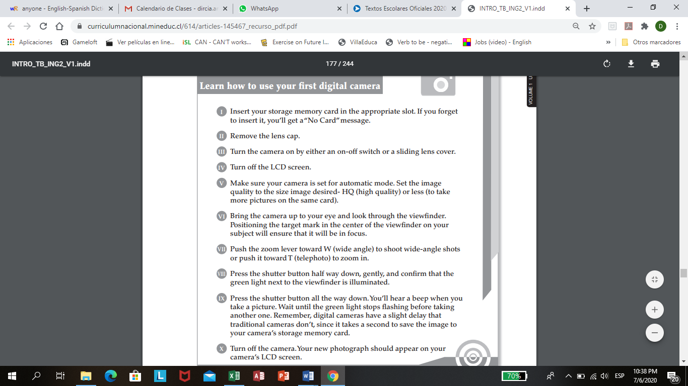LEARN HOW TO USE YOUR FIRST DIGITAL CAMERA.

Summarize the steps for using a digital camera and complete the diagram below. Remember to use connectors to link the instructions in each step.

1. Label the elements of a digital camera using the vocabulary provided.

LCD screen

Shutter button

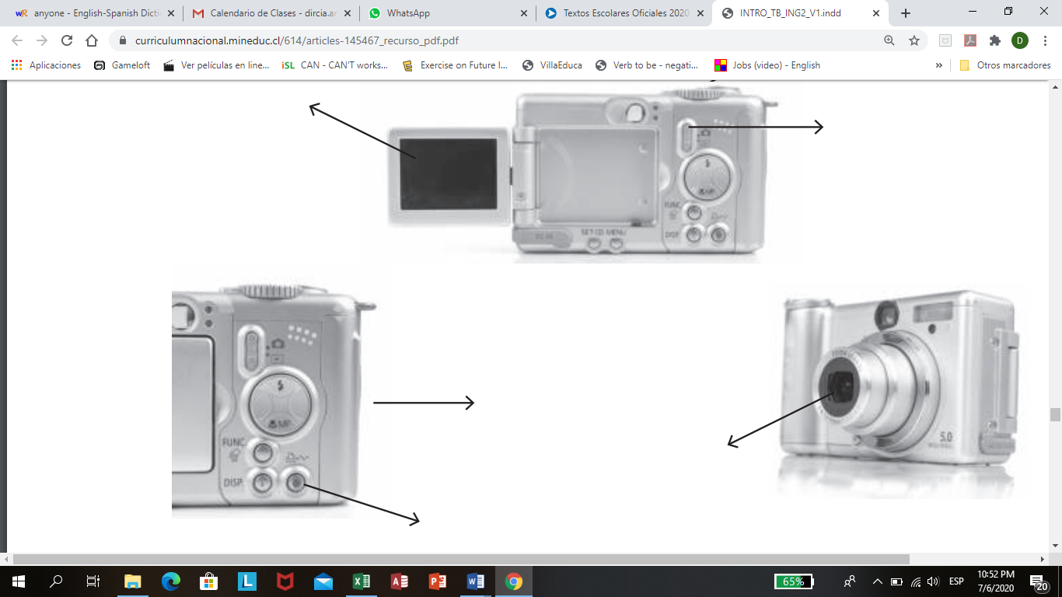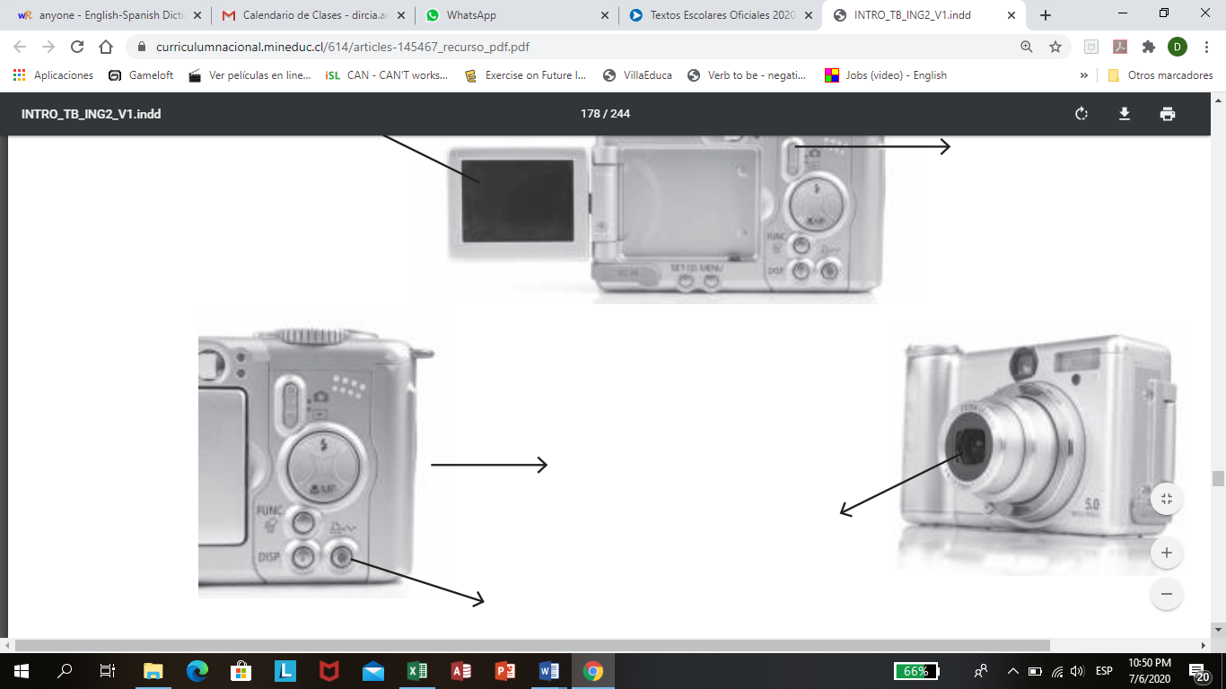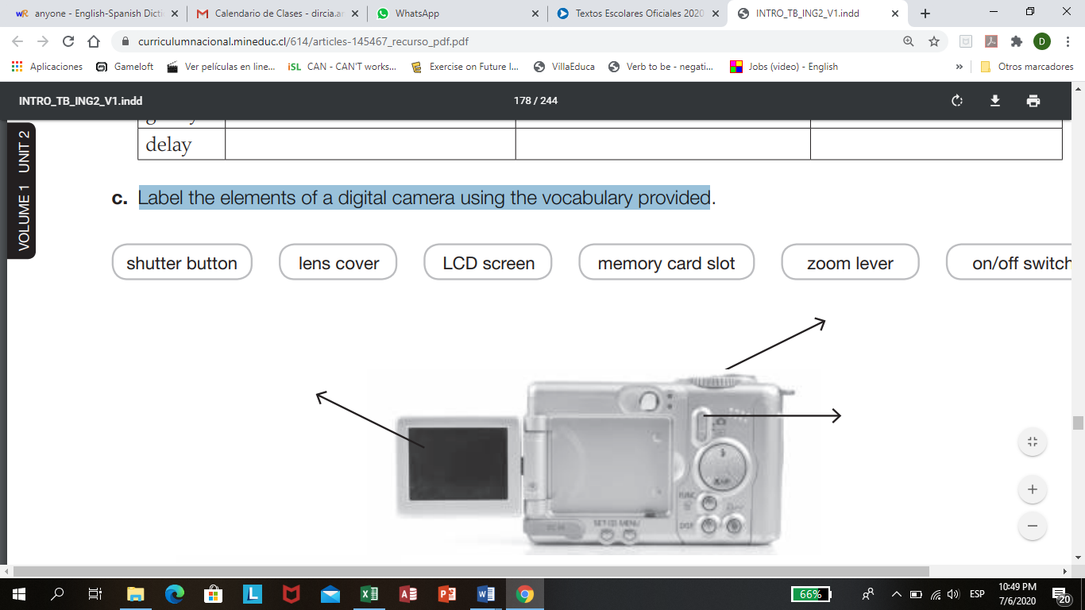

On/off switch

Zoom lever

Memory card slot

Shutter button

Lens cover

1. Have a look at the pictures and identify the different video games. Then answer the question below.

RACING GAME

WAR GAME

VIRTUAL REALITY GAME

PUZZEL GAME

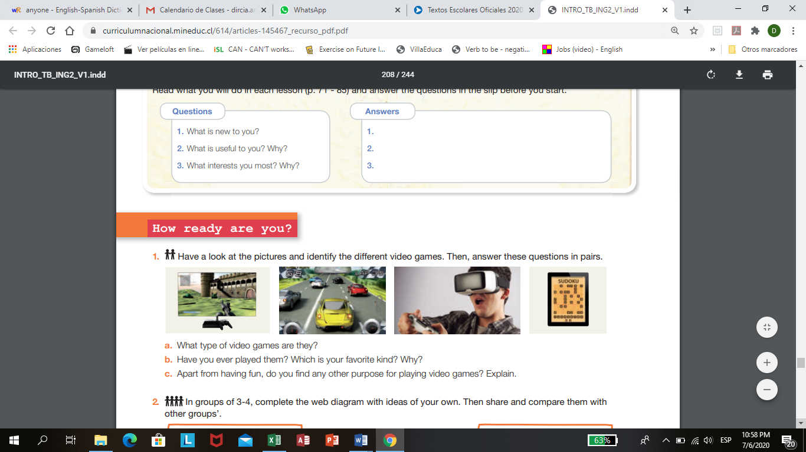

1. Have you ever played them? ………………………………………………..
2. Which is your favorite kind?........................................................................
3. Apart from having fun, do you find any other purpose for playing video games? …………………………………………………………………………...
4. Complete the diagram with ideas of your own.

DISADVANTAGES

TYPES

VIDEO GAMES

PURPOSES

ADVANTAGES

1. According to your opinion, what are the most popular social networking applications used at the moment? Name at least three. Number them according to “popularity” in your country.







