|  |  |
| --- | --- |
| antorcha liceo | **Liceo República Argentina**  Coyhaique  English Worksheets  Teacher Dircia Ampuero |

English worksheet

**1º medio**

Full Name: …………………………………… Grade: ………………………

**Objective**: To understand general and specific information in an informative text.

Instruction:

Complete the sentences in the worksheet and then send me an email, with the answers in color red or answer in your copybook and send me a photo, ampuero.catalan.dircia@gmail.com

**Delivery date, August, Tuesday 4th 2020.**

1. Complete the information in the Personal data.

PERSONAL DATA

|  |  |
| --- | --- |
| Name: | Surname: |
| Age: | Address: |
| Place of birth: | Personal Characteristics: |
| Hobbies: |  |
| Good at: | Experience: I have worked… |
|  |  |

1. Read the text and answer the questions below.

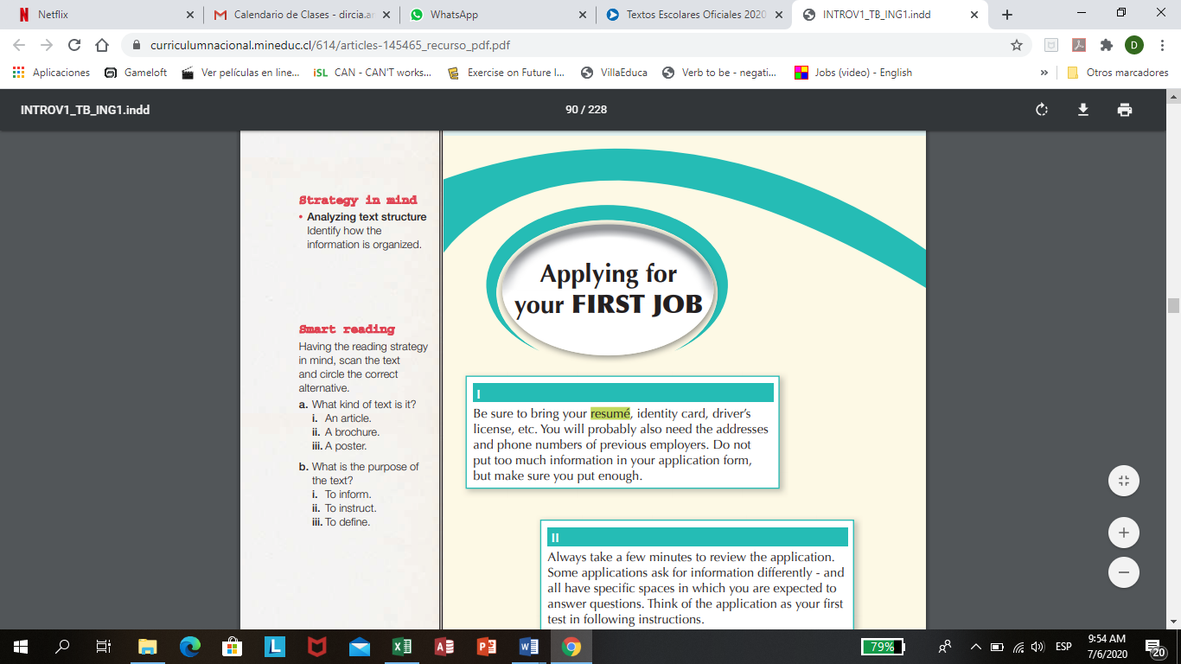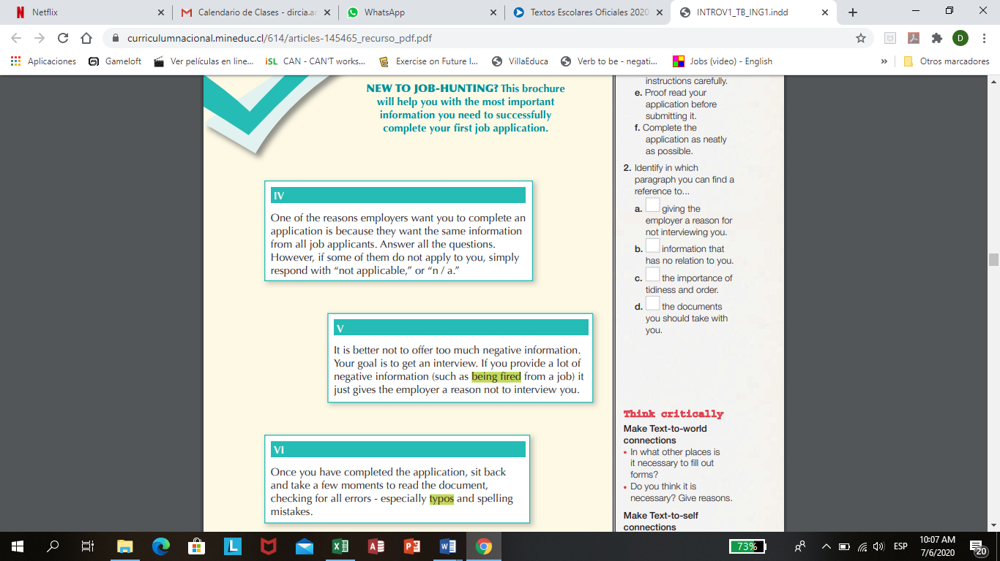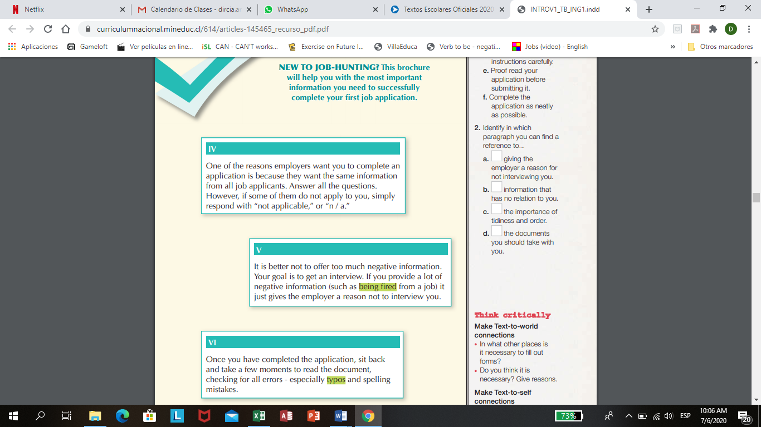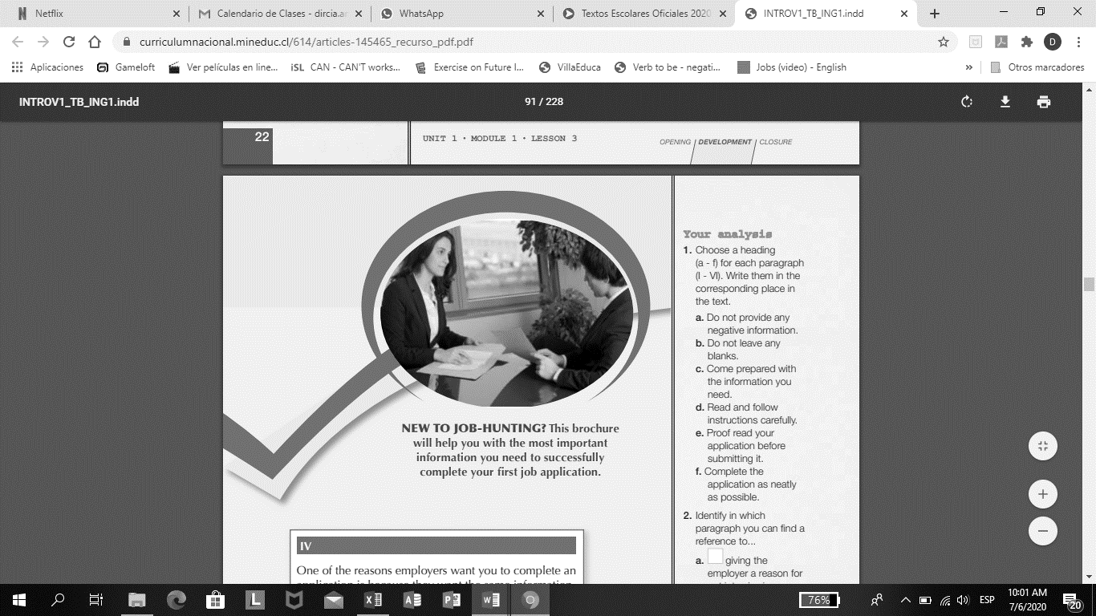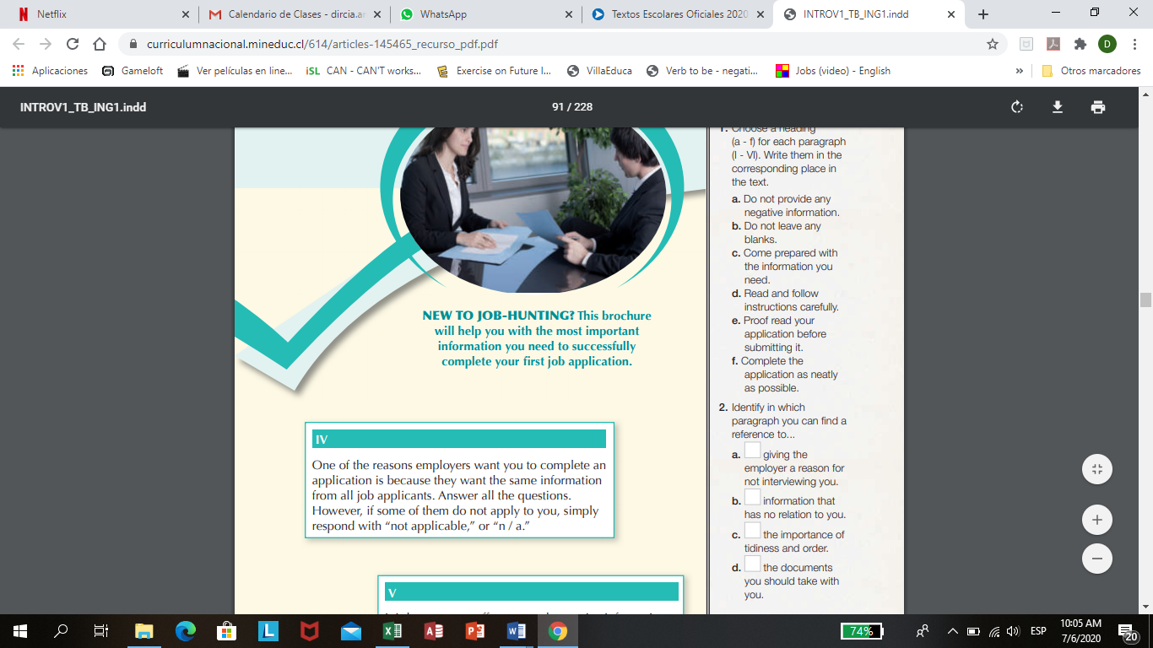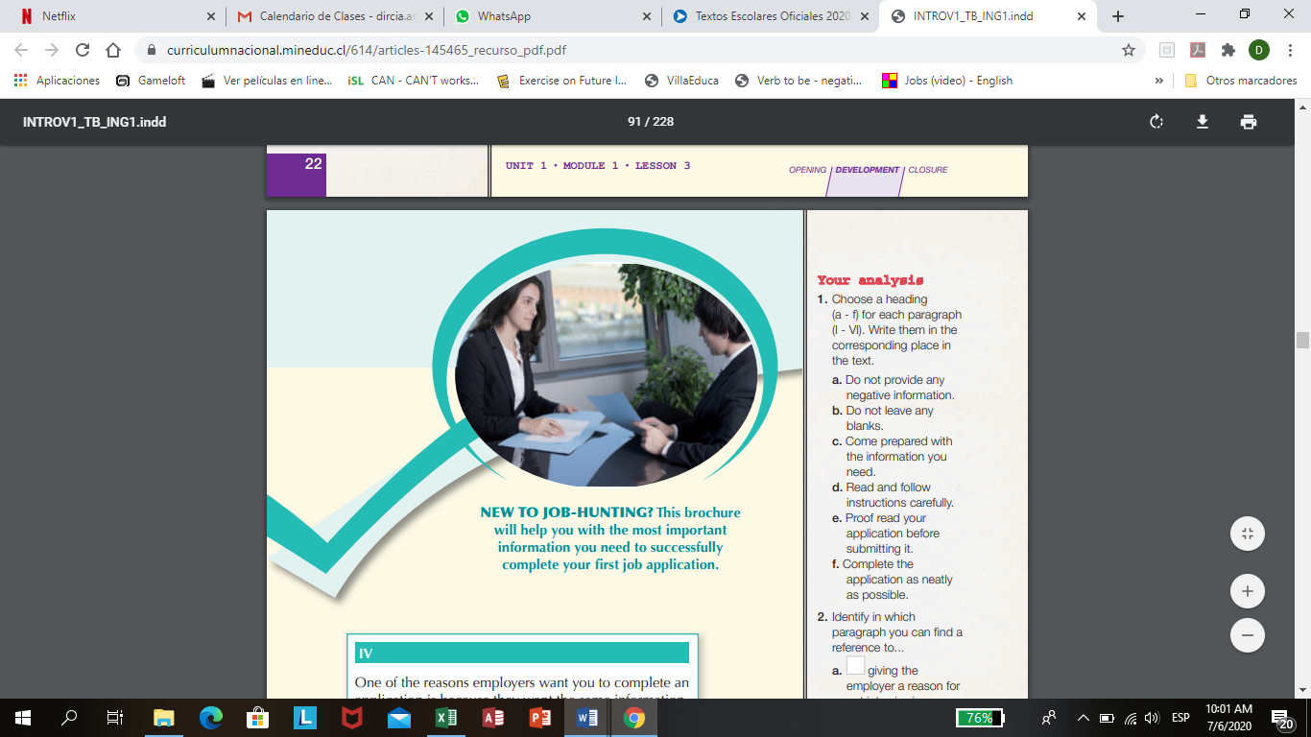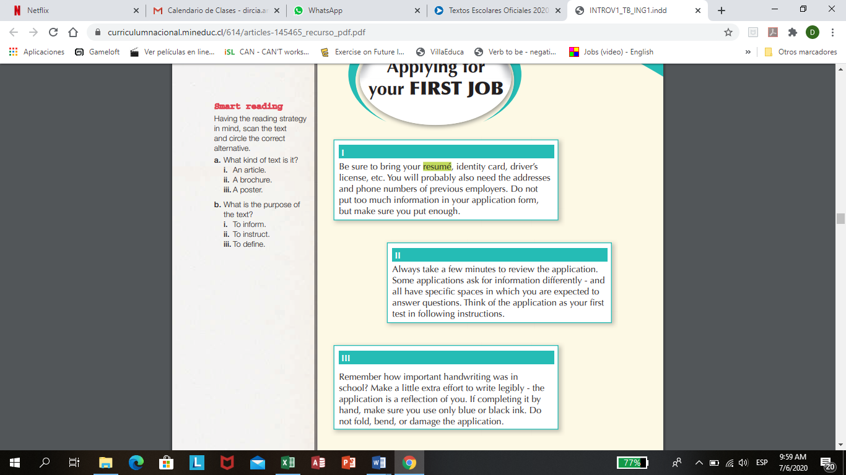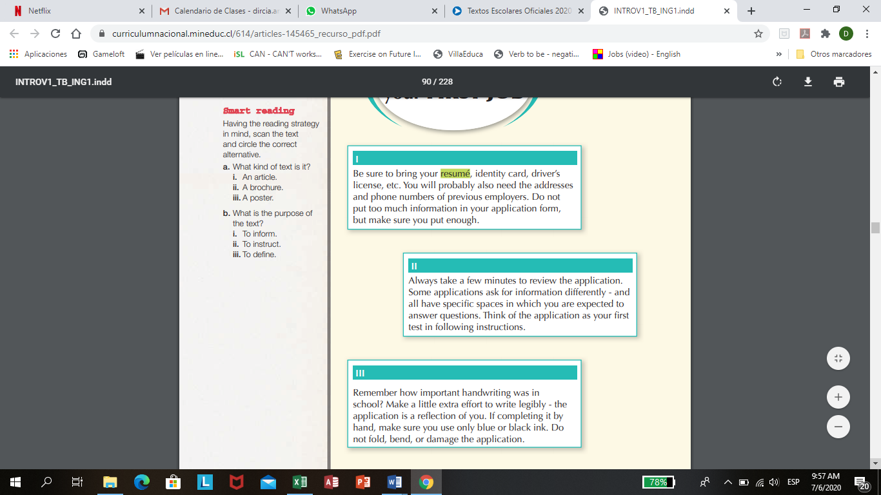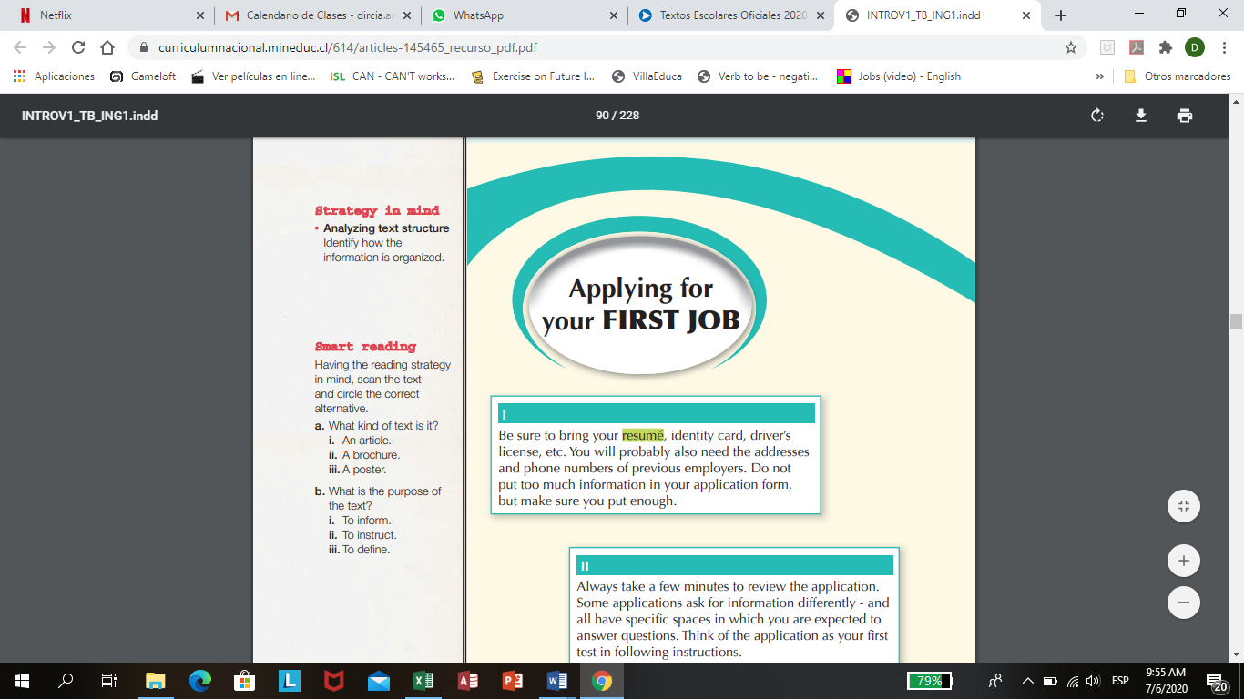

**VI**

**V**

**IV**

**III**

**I**

**II**

1. What kind of text is it?

i.an article.

ii. a brochure.

iii. a poster.

1. What is the purpose of the text?

i.to inform.

ii. to instruct.

iii. to define.

Choose a heading (a-f) for each paragraph (I-VI) write them in the corresponding place in the text.

1. Do not provide any negative information.
2. Do not leave any blanks.
3. Come prepared with the information you need.
4. Read and follow instructions carefully.
5. Proof read your application before submitting it.
6. Compete the application as neatly as possible.

Identify in which paragraph you can find a reference to…

1. Giving the employer a reason for not interviewing you.
2. Information that has no relation to you.
3. The importance of tidiness and order.
4. The documents you should take with you.
5. Look at this advertisement and identify the information related to the job, does it include all the information you need to apply? What is missing?

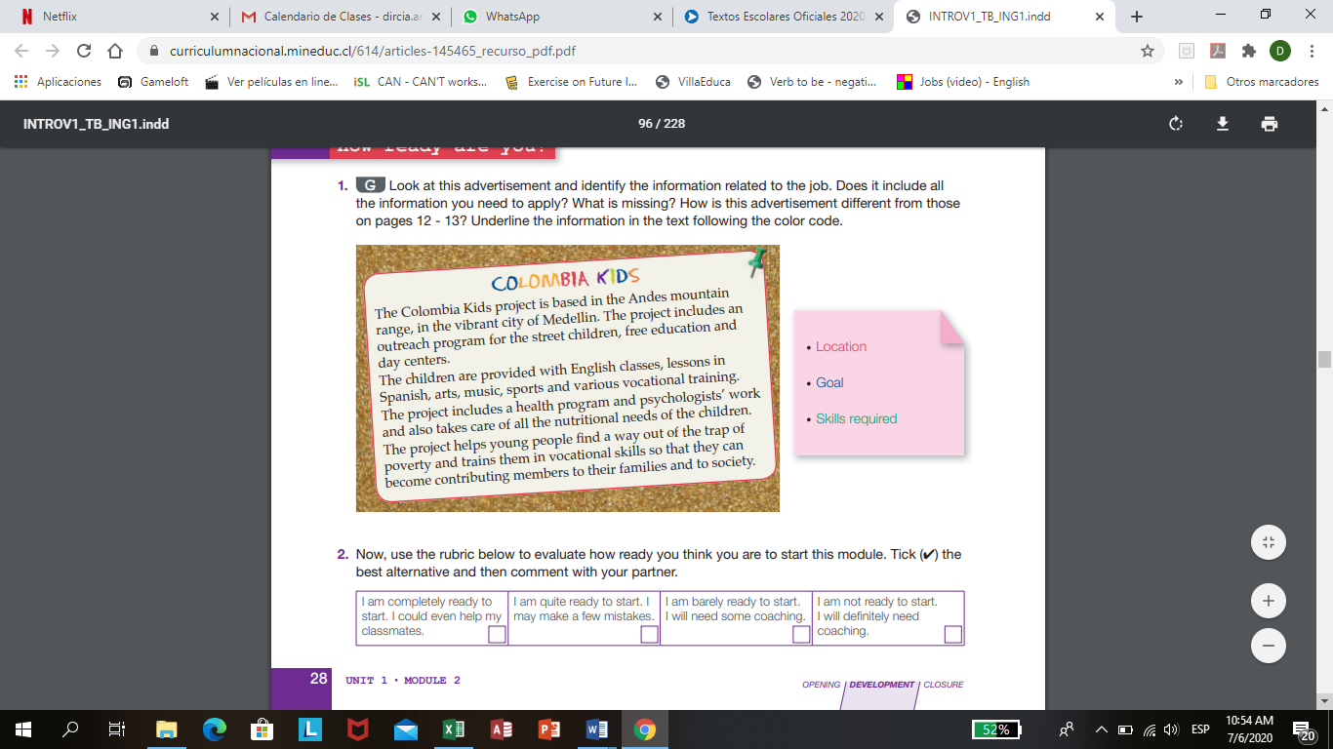

What information is missing? …………………………………………………………………………………………………

Write the information requires, find in the text.

Location:

Goal:

Skills required:

1. Look at the infographic created by Umum UK, and find the meaning for each unusual jobs in the UK.

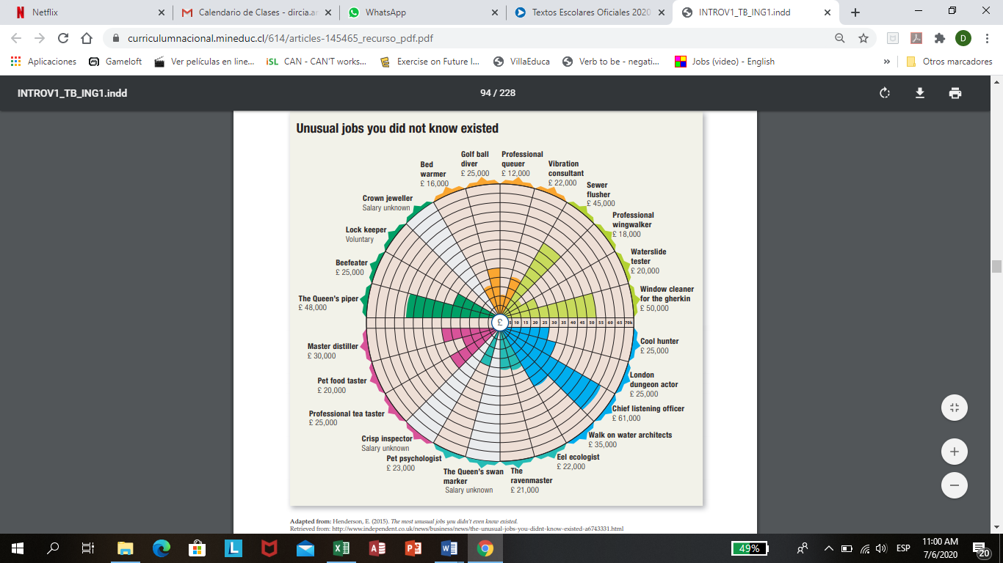

Bed warmer: Golf ball diver: Professional queuer:

Vibration consultan: Sewer flusher:

Professional wingwalker: Waterslide tester:

Window cleaner for the gherkin: Cool hunter:

London dungeon actor: Chief listening officer:

Walk on water architects: Eel ecologist:

The ravenmaster: The Queen´s swan marker:

Pet psychologist: Crisp inspector:

Professional tea tester: Pet food taster: Master distiller:

The Queen´s piper: Beefeater: Lock keeper:

Crown jeweler:

Which are the best paid unusual jobs?

…………………………………………………………………………………………..

Characterize these jobs, such as: interesting, weird, dangerous and stressful.

|  |  |  |  |
| --- | --- | --- | --- |
| INTERESTING | WEIRD | DANGEROUS | STRESSFUL |
|  |  |  |  |
|  |  |  |  |
|  |  |  |  |
|  |  |  |  |
|  |  |  |  |
|  |  |  |  |
|  |  |  |  |

1. Read these three definitions about what a volunteer is or does and choose the correct definition.

c. A volunteer is a person who performs or offers to perform a service out of his or her own free will but requires a payment.

b. A volunteer is a person who performs or offers to perform a service because he/she has nothing else to do.

a.A volunteer is a person who performs or offers to perform a service out of his or her own free will without payment.

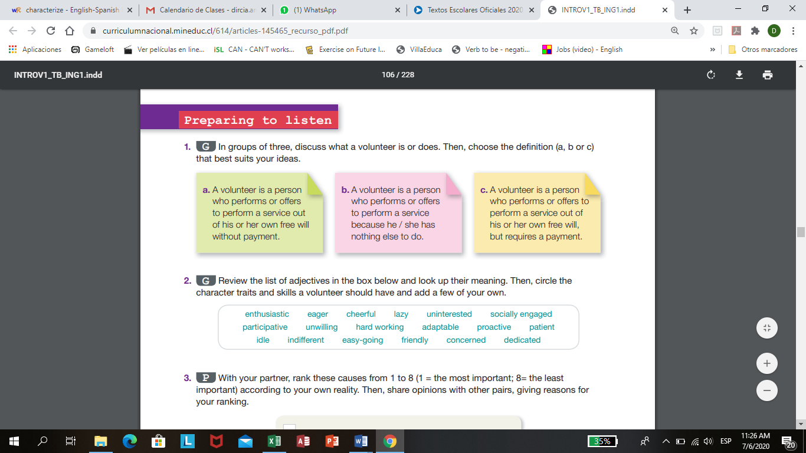Read the list of adjectives in the box below and look u their meaning. Then circle the character traits and skills a volunteer should have.

Enthusiastic: unwilling:

Eager: hard working:

Cheerful: adaptable:

Lazy: proactive:

Uninterested: patient:

Socially engaged: idle:

Participative: indifferent:

Easy-going: friendly:

Concerned: dedicated: