|  |  |
| --- | --- |
| antorcha liceo | **Liceo República Argentina**  Coyhaique  English Worksheets  Teacher Dircia Ampuero |

English worksheet

2º medio

Full Name: …………………………………… Grade: ………………………

**Objective**: To select and use different strategies to identify specific information in the text.

Instruction:

Complete the sentences in the worksheet and then send me an email, with the answers in color red or answer in your copybook and send me a photo,

ampuero.catalan.dircia@gmail.com

**Delivery date, June, Tuesday 7th 2020.**

1. **Read the text and answer the question.**

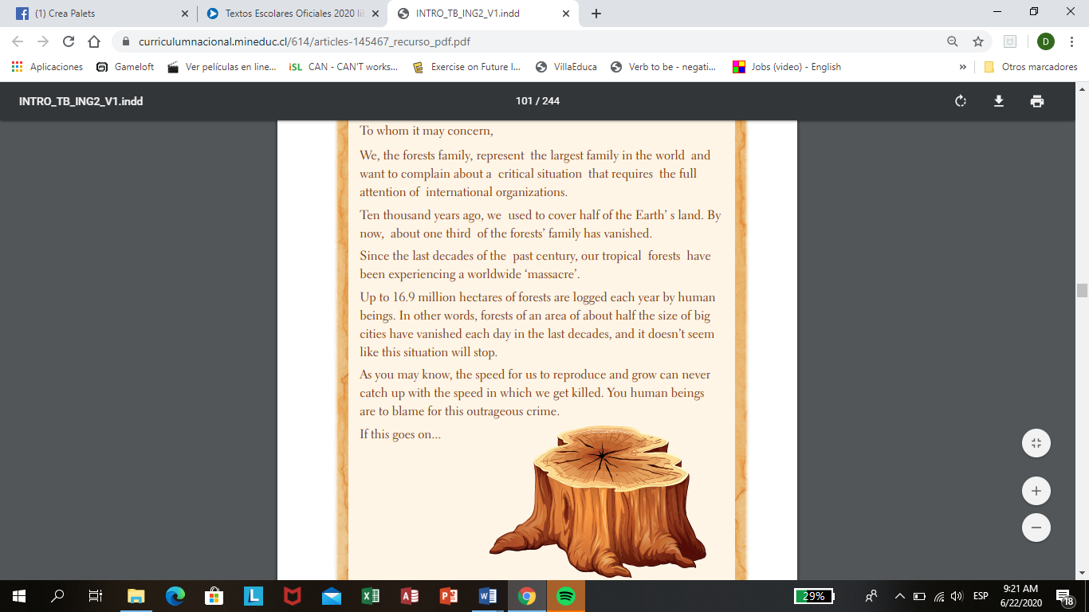

1. Who is the writer of the letter? Who is the intended audience?

…………………………………………………………………………………..........

1. Is the problem described in the letter a global issue? Why? Why not?

………………………………………………………………………………..............

1. Which places in Chile are being affected by this problem?

…………………………………………………………………………………………

**1b. Which of these are consequences of damaging the forests? Tick (✔) the ideas that are true.**

1. …………… Land surface is exposed to sunshine and rainstorms.
2. …………… The loss of soil and its nutrients makes it hard for the forest to revive.
3. …………... The culture and customs of indigenous tribes that live in the forests disappear.
4. …………… Many animals are forced to migrate or they just die.
5. ……………. The dwellings and food of some animals and plants are cleared out.
6. 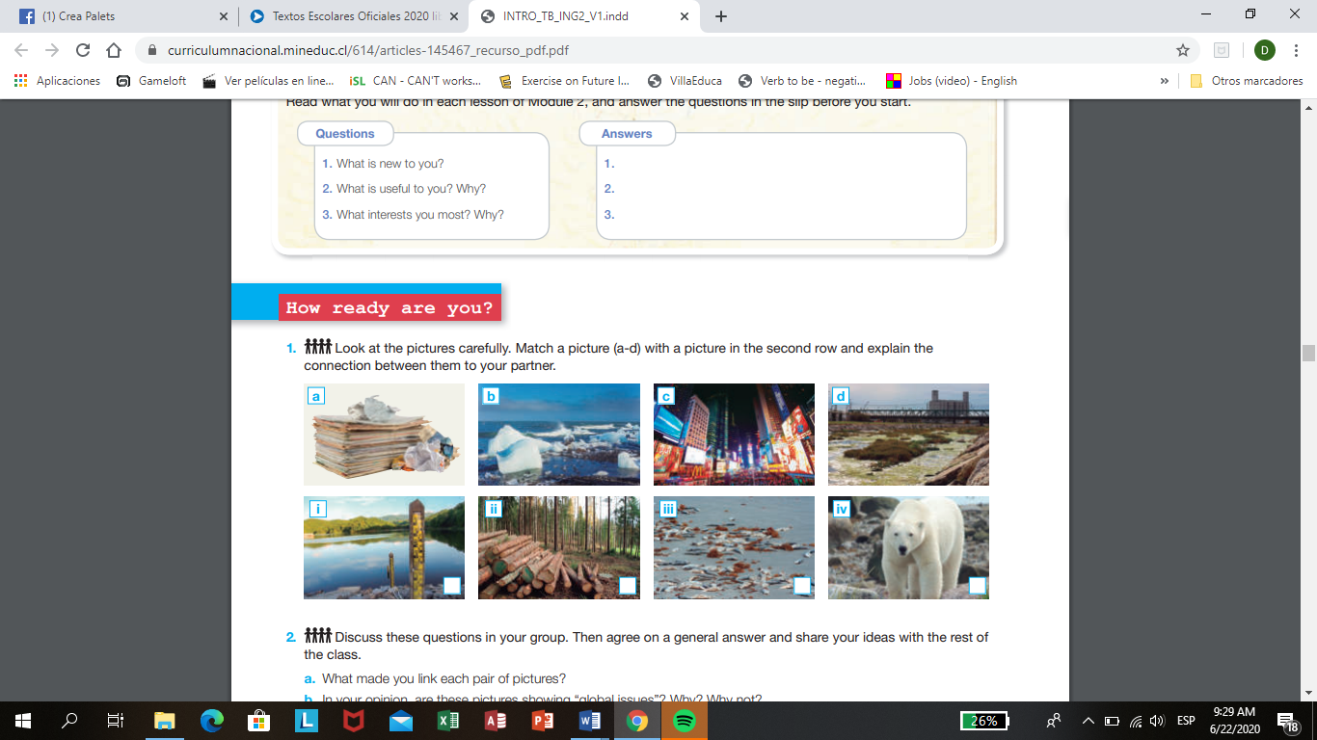**Look at the pictures carefully. Match a picture (a-d) with a picture in the second row and explain the connection. You can do it in Spanish.**

In your opinion, are these pictures showing “global issues”? Why? Why not?You can answer in spansih.

……………………………………………………………………………………………………………………………………………………………………………………………………………………

1. 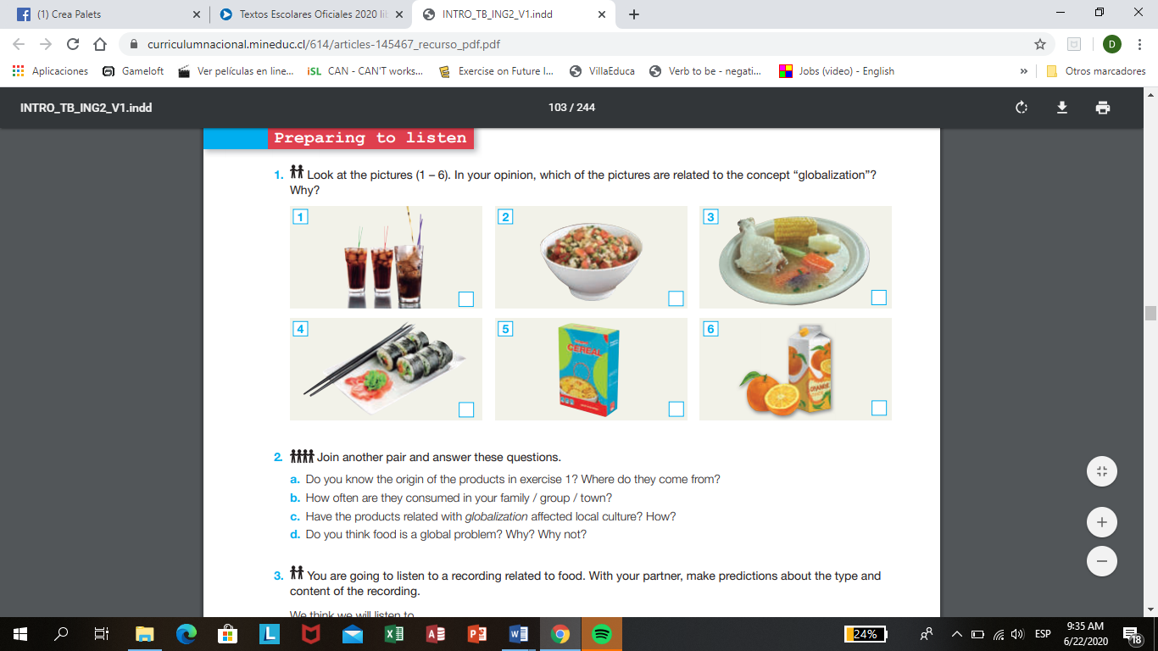**Look at the pictures (1 – 6). In your opinion, which of the pictures are related to the concept “globalization”? Put a √ in the picture.**

**Answer in Spanish if you want to.**

1. Do you know the origin of the products in exercise 1? Where do they come from? ………………………………………………………………………………..
2. How often are they consumed in your family / group / town?

………………………………………………………………………………………...

1. Have the products related with globalization affected local culture? How?

………………………………………………………………………………………...

1. **Create a postcard about a problem issue, use your imagination, color and write different sentences related to the problem you choose.**