|  |  |
| --- | --- |
| antorcha liceo | **Liceo República Argentina**  Coyhaique  English Worksheets  Teacher Dircia Ampuero |

English worksheet

**1º medio**

Full Name: …………………………………… Grade: ………………………

**Objective**:

* To develop communicative skills to express ideas about working life.
* To understand main ideas and specific information in oral and written texts about jobs, professions and working life.

Instruction:

Complete the sentences in the worksheet and then send me an email, with the answers in color red or answer in your copybook and send me a photo, ampuero.catalan.dircia@gmail.com

**Delivery date, June, Tuesday 23rd 2020.**

1. Think about the jobs and occupations your family, friends and neighbors have. Choose two and fill in the table with brief information.

Example: **Job**: Carpenter **skills**: math skills

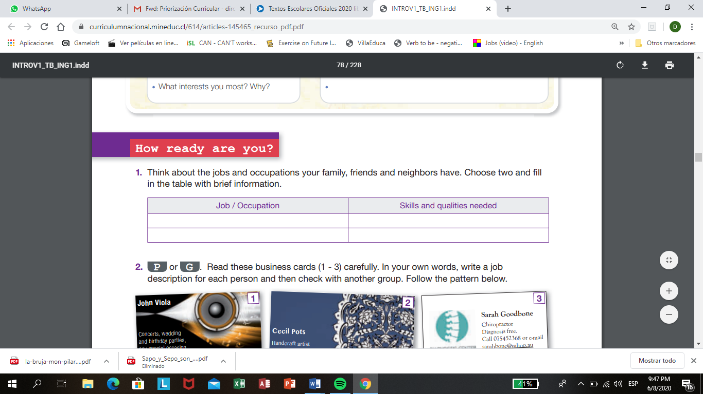

1. 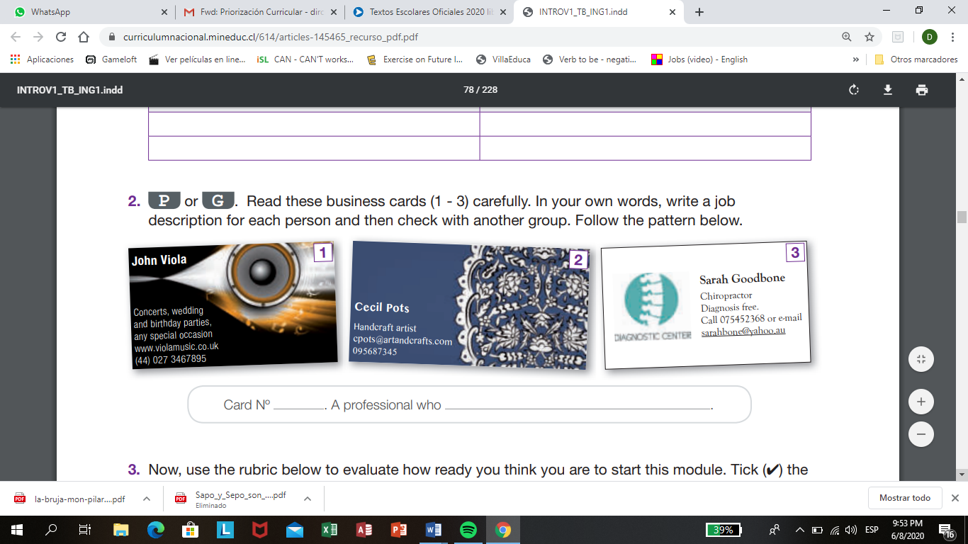Read these business cards (1 - 3) carefully. In your own words, write a job description for each person, follow the pattern below.
2. Write a short description about a specific job, following the example.

|  |  |
| --- | --- |
| Baker | A person who bakes cakes and bread. |
| Driver |  |
| Astronomer |  |
| Hairdresser |  |
| Reporter |  |
| Chef |  |
| Actor |  |

1. Look at the pictures and write their jobs.

ACTRESS REPORTER SOCCER PLAYER CHEF SINGER

PRESIDENT





1. Read these two job advertisements and identify which job (number I or number II).

a……. allows on-line application. d…... pays less than US$10 per hour.

b……. is a part-time position. e.…. provides paid training.

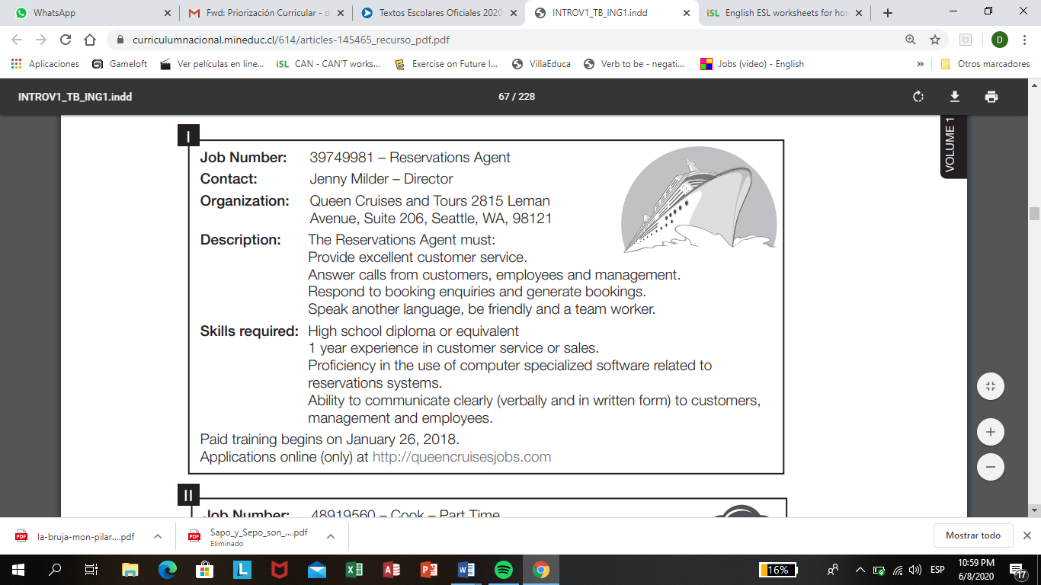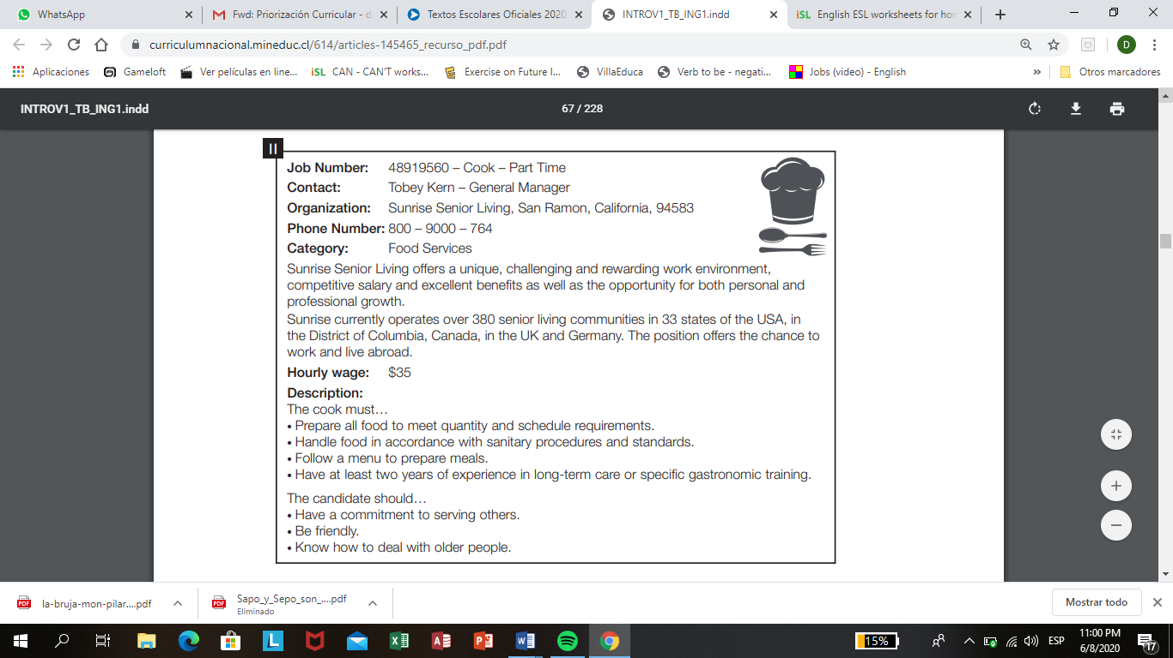c……. is based in Seattle. f……requires previous experience.

1. Read the job advertisements and find the following information. Complete the table.

Duties: Labores Experience: Experiencias

Hourly wage: salario por hora contact´s position: Posición del contacto

Job numbers: Número del trabajo

|  |  |  |
| --- | --- | --- |
| **Information** | **Number I** | **Number II** |
| Duties |  |  |
| Experience |  |  |
| Hourly wage |  |  |
| Contact´s position |  |  |
| Job numbers |  |  |

1. Read job number I and number II again and write t (true) or F (false).

a. …………. Job number 1 involves receiving and making phone calls.

b. …………. Job number 2 requires knowledge of sanitary procedures.

c. …………. People applying for job number 2 must speak German.

d. ………… Wages for job number 1 depend on experience.

e. ………… You can apply for Job number 1 on the phone.

f. …………. The two jobs require social skills.