|  |  |
| --- | --- |
| antorcha liceo | **Liceo República Argentina**  Coyhaique  English Worksheets  Teacher Dircia Ampuero |

English worksheet

**4º medio**

Full Name: …………………………………… Grade: ………………………

**Objective**: Read and listen to texts about rights and responsibilities and express ideas about this topic in an effective and creative way.

Instruction:

Complete the sentences in the worksheet and then send me an email, with the answers in color red or answer in your copybook and send me a photo,

ampuero.catalan.dircia@gmail.com

**Delivery date, July, Friday 9th 2020.**

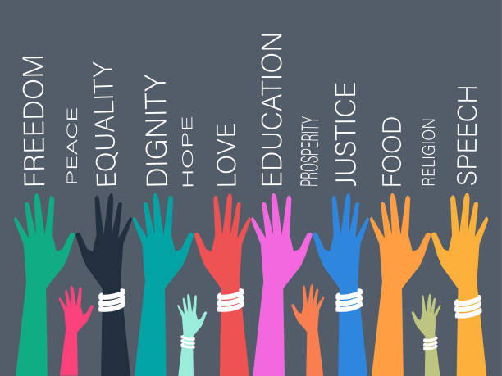**Human Rights and Responsibilities**

What means rights:

What means responsibilities:

1. Look at the picture below and write some human rights and your responsibilities.

Responsibilities

Rights

Find in the dictionary…

Citizen: passport: Duties: citizenship:

1. Read the article and answer the questions below.

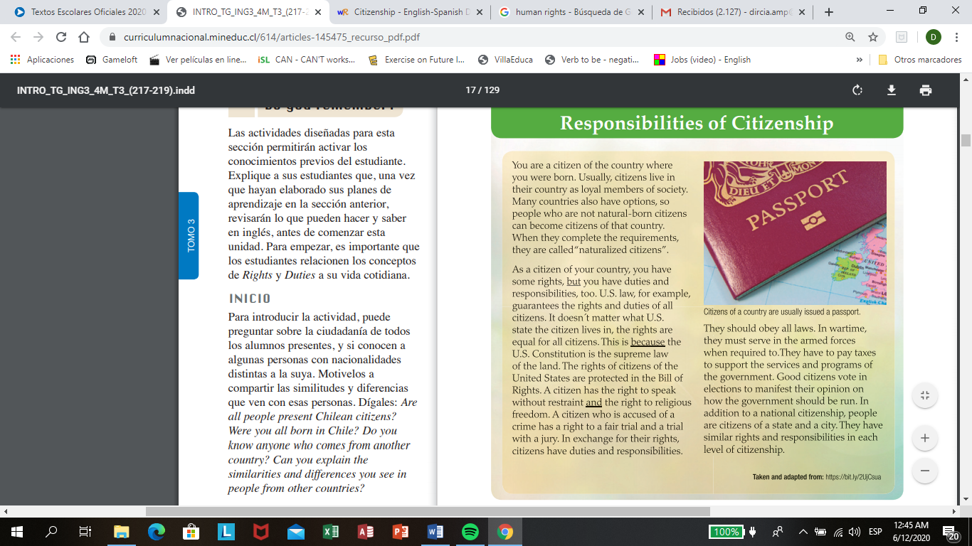

1. Can you define “citizen” in your own words

…………………………………………………………………………………..

1. What is a naturalized citizen?

…………………………………………………………………………………..

1. Which are some of the duties and responsibilities of a citizen?

…………………………………………………………………………………..

1. What are two rights guarantees to citizens in the U.S constitution?

………………………………………………………………………………….

1. Which of the underline words in the text express:

But: pero Because: porque And: y

1. Addition
2. Contrast
3. Reason
4. 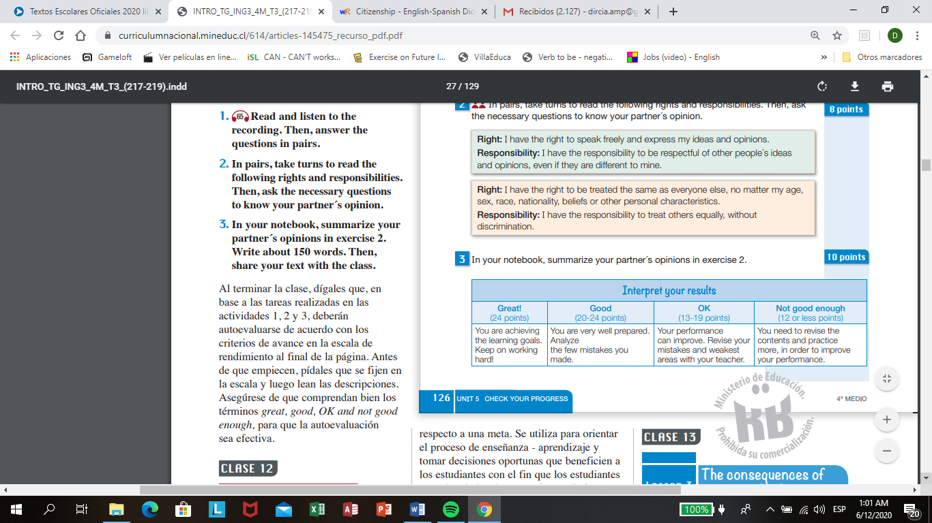Read the examples for rights and responsibilities. And translate into Spanish in your own words.

………………………………………………………………………………………………………………………………………………………………………………………………………………………………………………………………………………………………………………………….......

1. Have a look at the pictures (a-d) and decide which human rights they illustrate.

Freedom Right to migration Religious Freedom

Freedom of Speech

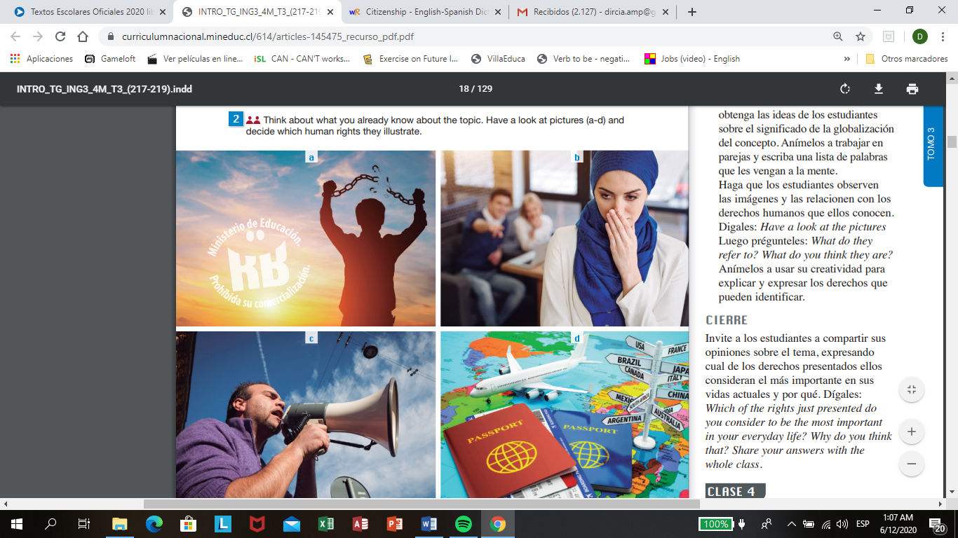

1. Can you write some others human rights:

………………………………………………………………………………………………………………………………………………………………………………………………………………………………………………………………………………………………………………………………………………………………………………………………

Write the meaning for these words…

Freedom from slavery:

Right to live:

Right to a fair trial:

Freedom and equality:

1. Read the short paragraph and answer.

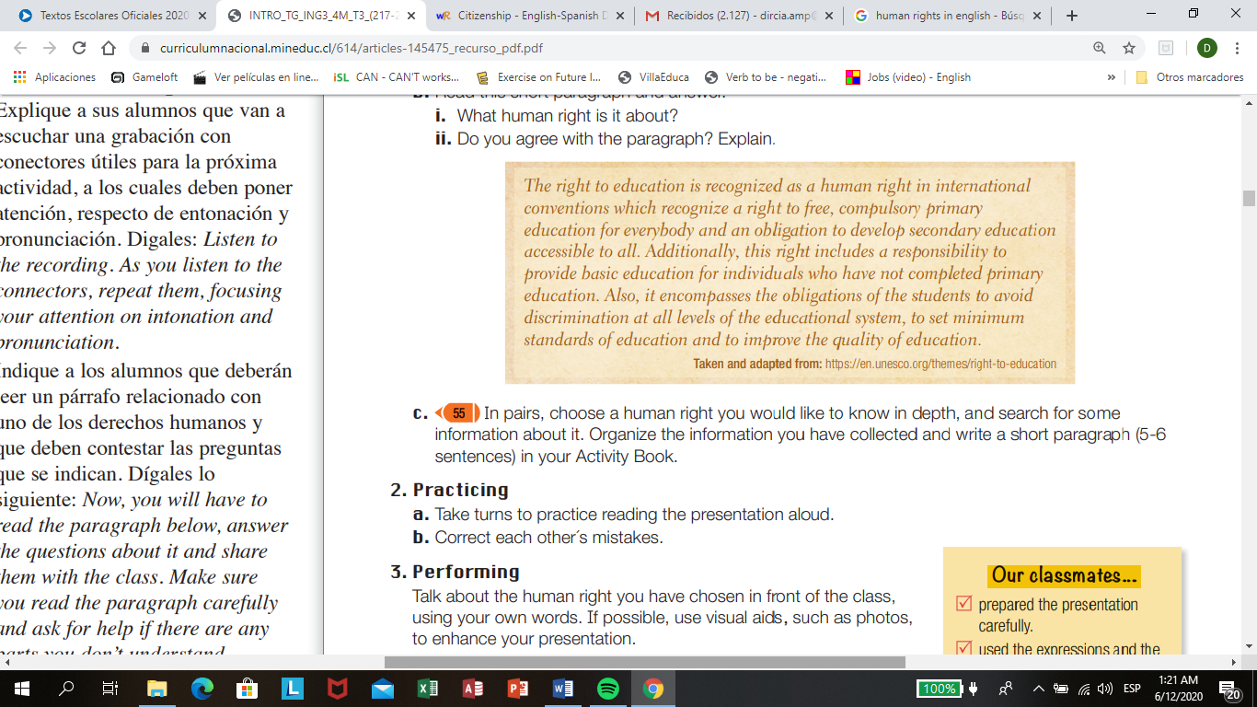

What human right is it about? ………………………………………………………………………………..

1. 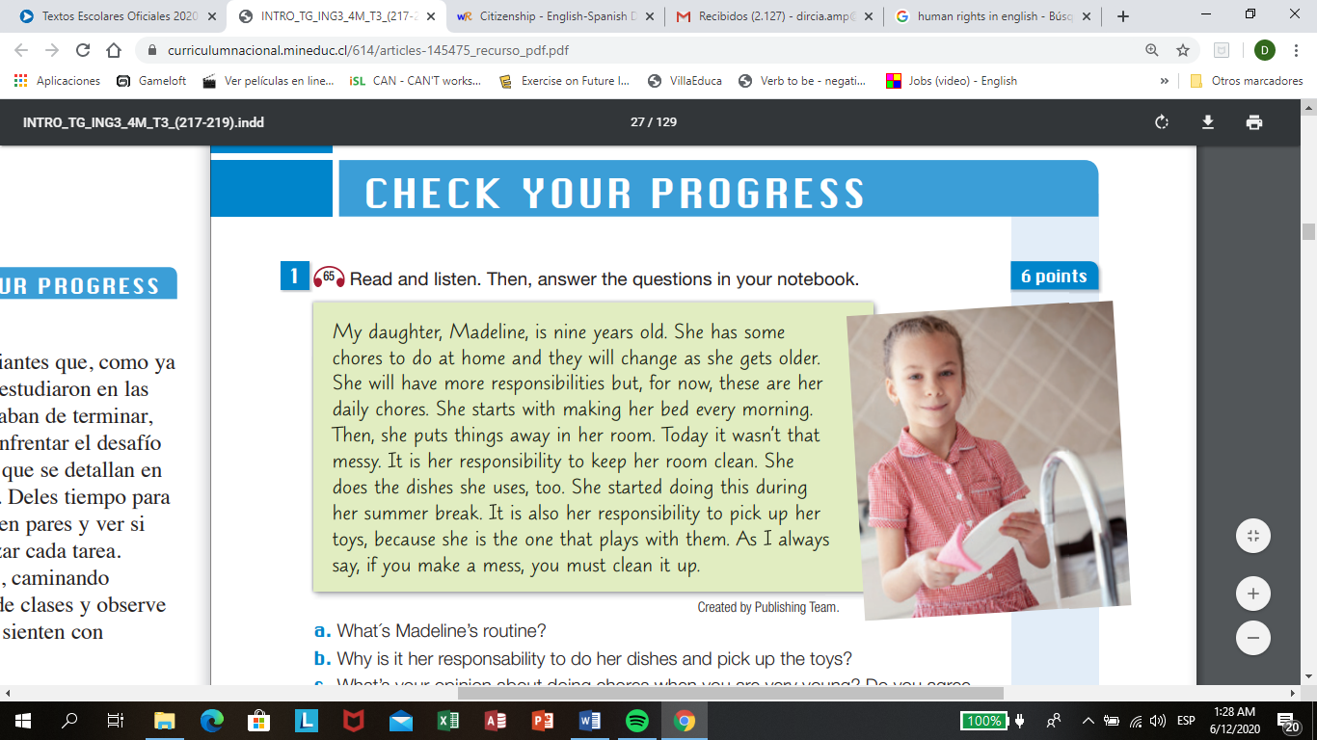According to rights and responsibilities here we have a text about a girl´s responsibilities. Read and answer some questions.

What are Madeline´s responsibilities?

……………………………………………………………………………….

Why is it her responsibility to do her dishes and pick up the toys?

……………………………………………………………………………….

What´s your opinion about doing chores when you are very young? You can write your answer in Spanish. \***Chores: tareas del hogar.**

……………………………………………………………………………………………………………………………………………………………………………………………………………………

1. In your opinion, write five human rights from the most important to the less for you.
2. ……………………………………………………….
3. ……………………………………………………….
4. ……………………………………………………….
5. ……………………………………………………….
6. ……………………………………………………….
7. **Create a postcard about Human Rights, use your imagination.**

In a paper you are going to create a postcard, use pencil colors or paint.

Append your paper with the worksheet.