|  |  |
| --- | --- |
| antorcha liceo | **Liceo República Argentina**  Coyhaique  English Worksheets  Teacher Dircia Ampuero |

English worksheet

**3º medio**

Full Name: …………………………………… Grade: ………………………

**Objective**: to show comprehension of texts, and apply speaking and writing strategies to express ideas about the texts.

Instruction:

Complete the sentences in the worksheet and then send me an email, with the answers in color red or answer in your copybook and send me a photo, ampuero.catalan.dircia@gmail.com

**Delivery date, July, Friday 10th 2020.**

1. 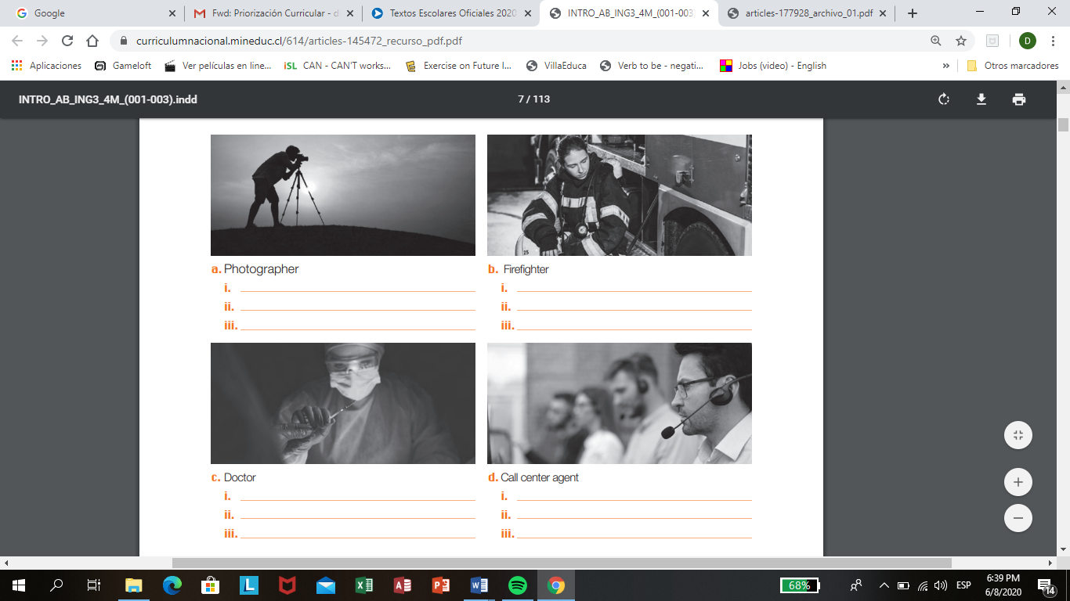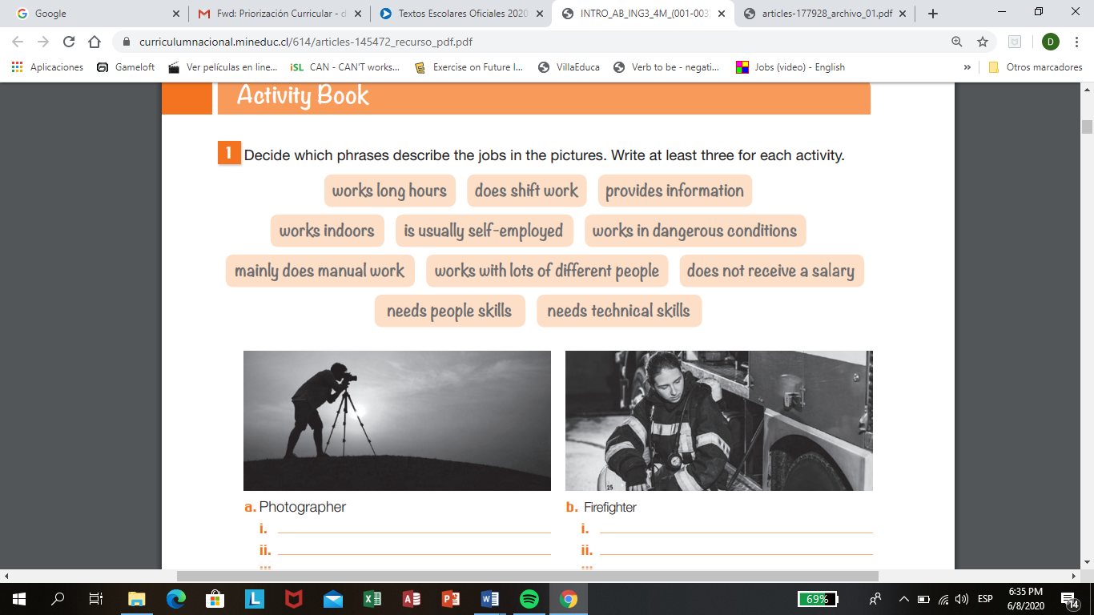**Decide which phrases describe the jobs in the pictures. Write at least three for each activity.**
2. **Look at the pictures and answer the questions.**

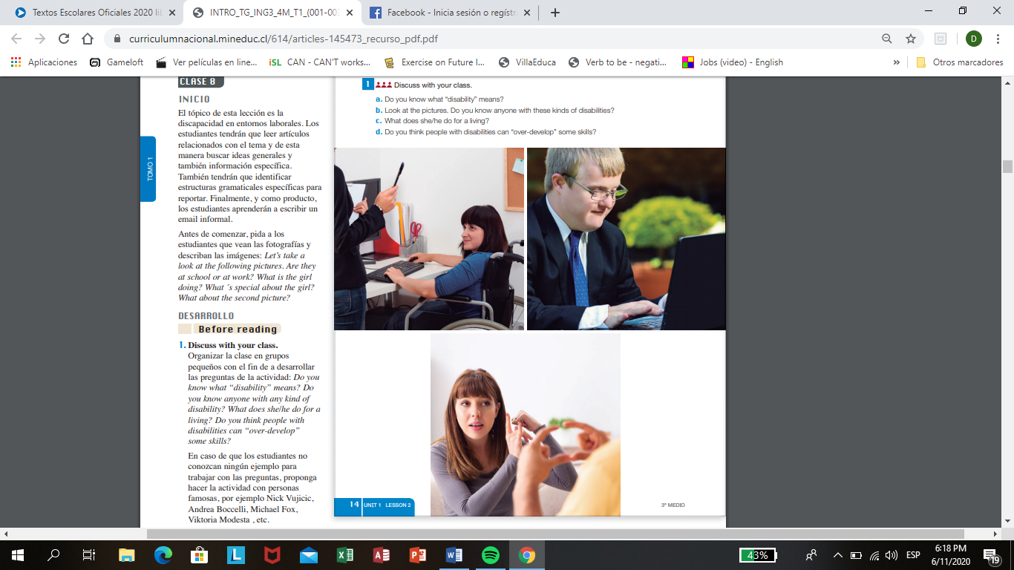



1. Do you know what “disability” means?

…………………………………………………………………………………..

1. Do you think people with disabilities can over develop some skills?

…………………………………………………………………………………..

1. 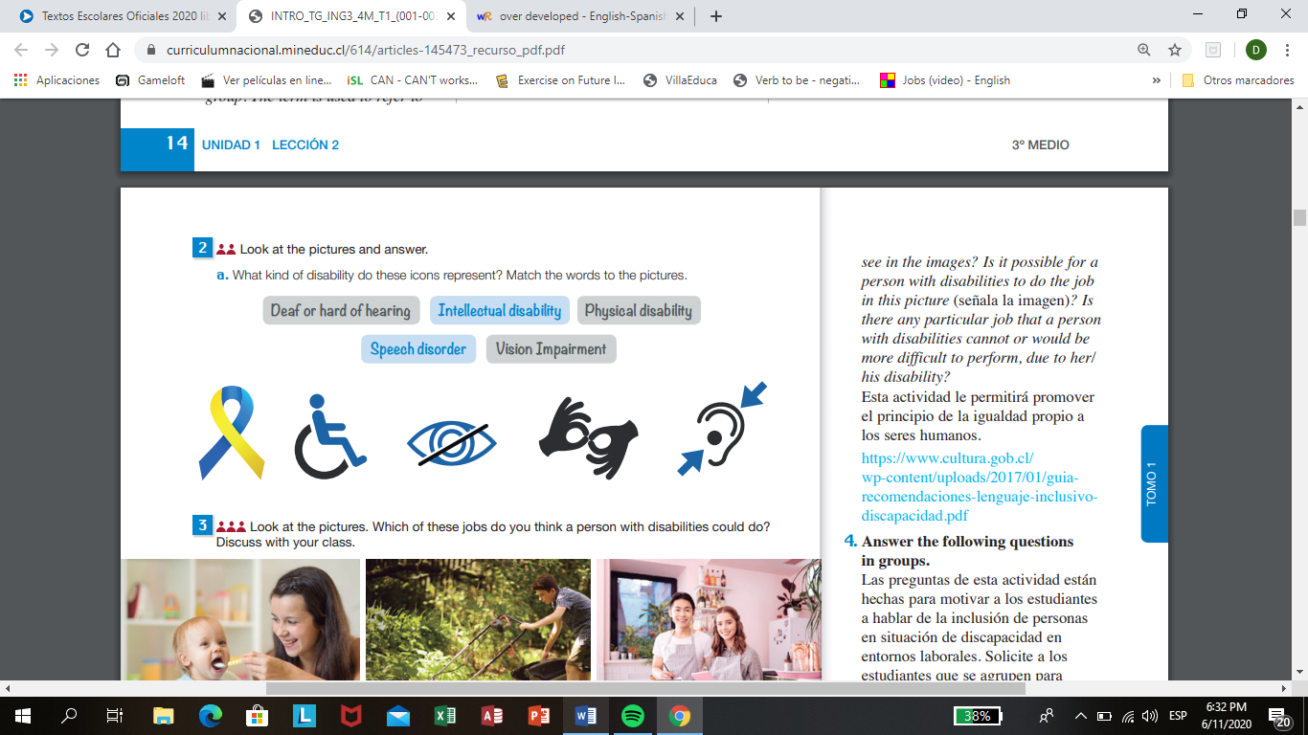**What kind of disability do these icons represent? Match the words to the pictures.**
2. 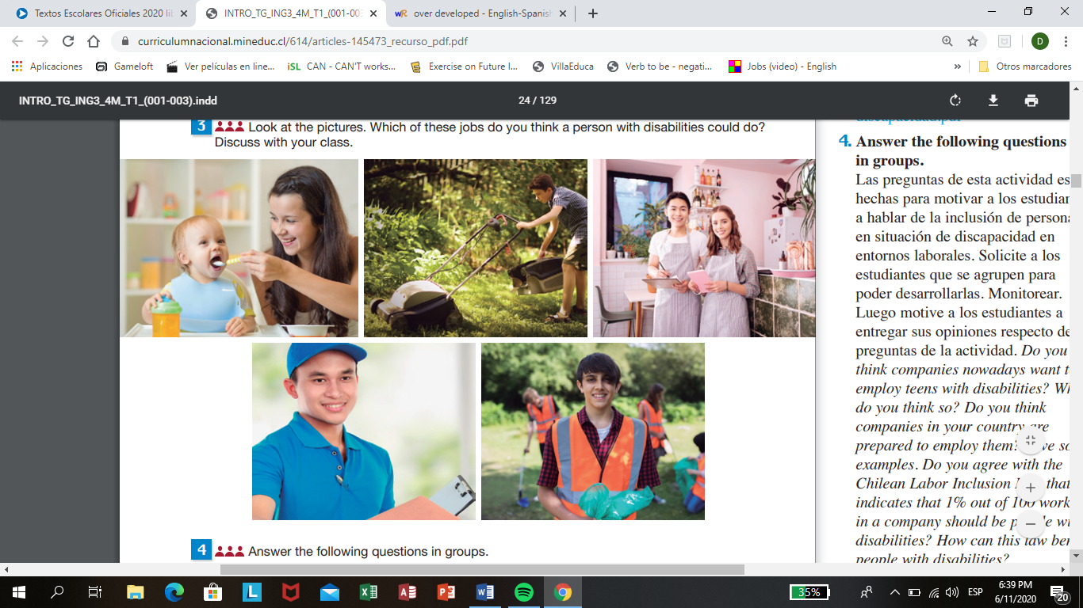**Look at the pictures and choose which of these jobs do you think a person with disabilities could do? Give a number from 1 to 5.**
3. Read the text and answer the questions.

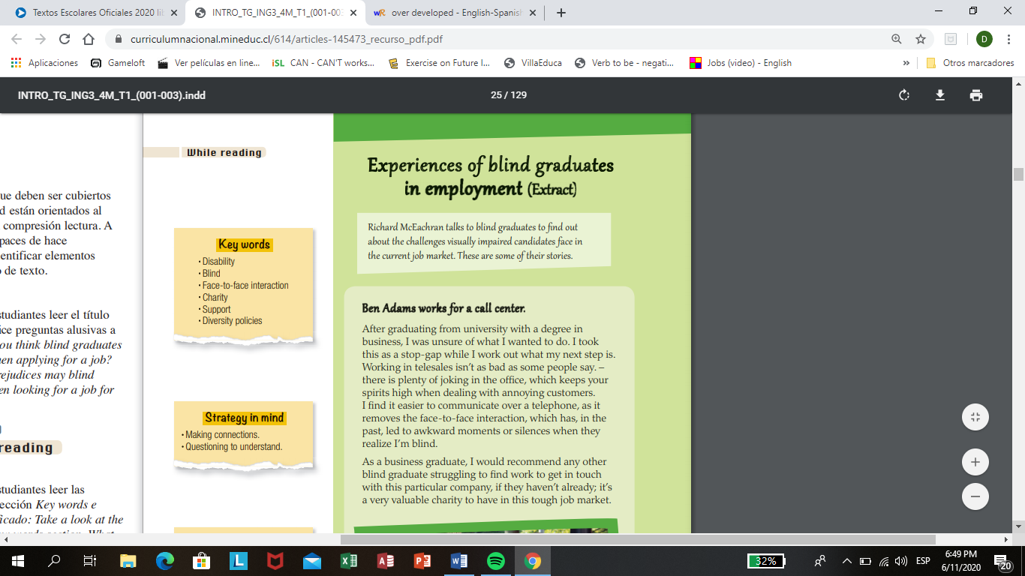

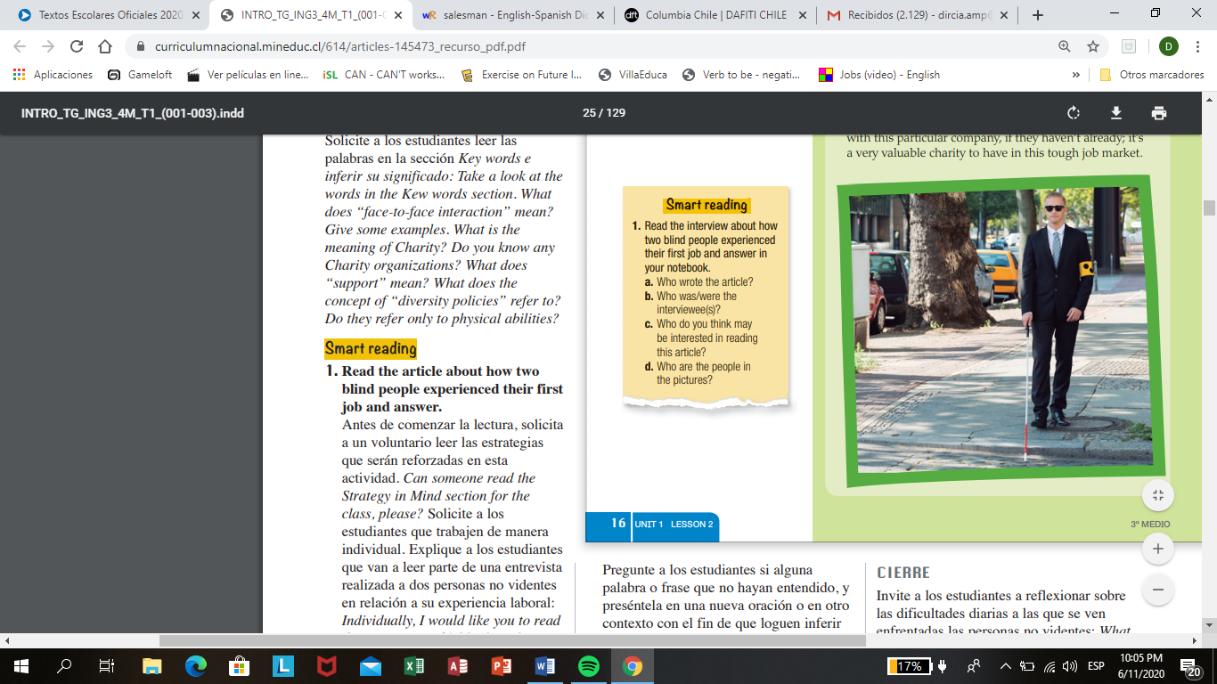

1. What is the disability of the person in the text?

………………………………………………………………

1. Where does he work?

………………………………………………………………

1. What is his name?

………………………………………………………………

1. What does he do in his job?

………………………………………………………………

1. **Find in the dictionary the words below.**

* Disability: ………………………… - face to face: ………………………………
* Blind: ……………………………. - Charity: …………………………….
* Support: ………………………… - Diversity policies: …………………………..

1. **Choose the correct alternative.**

* The name of the person in the text is…

1. Paul b) Ben c) Steve

* He is a …

1. Doctor b) Salesman c) Chef

* He works in a …

1. Drugstore b) Call center c) post office
2. Read the text and answer the question.

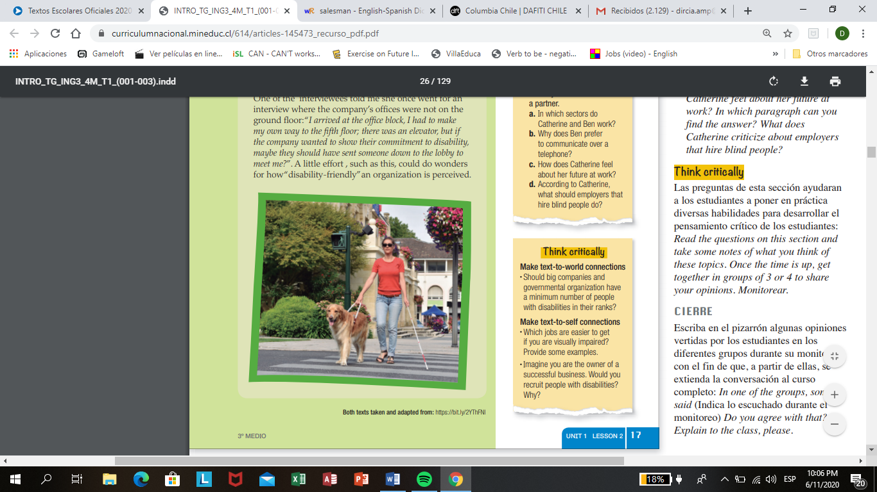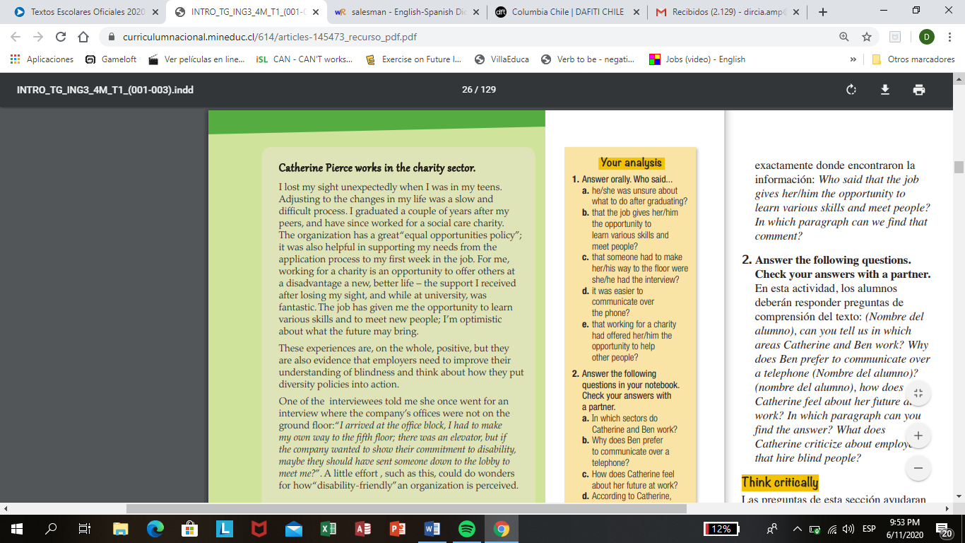

1. In which sector do Catherine work?

………………………………………………………………………………………….

1. How does Catherine feel about her future at work?

………………………………………………………………………………………….

1. According to Catherine, what should employers that hire blind people do?

…………………………………………………………………………………………..

1. Write about a person that has a disability, the person can be famous or a member of your family a friend etc.

Find information about the name, if his/her has a job, the name of the job, age, name of the country. You can include some special information if you want to.

Disability Person

1. **Look the picture and write the name for each job. And what kind of skills did the applicants need to get their jobs?**

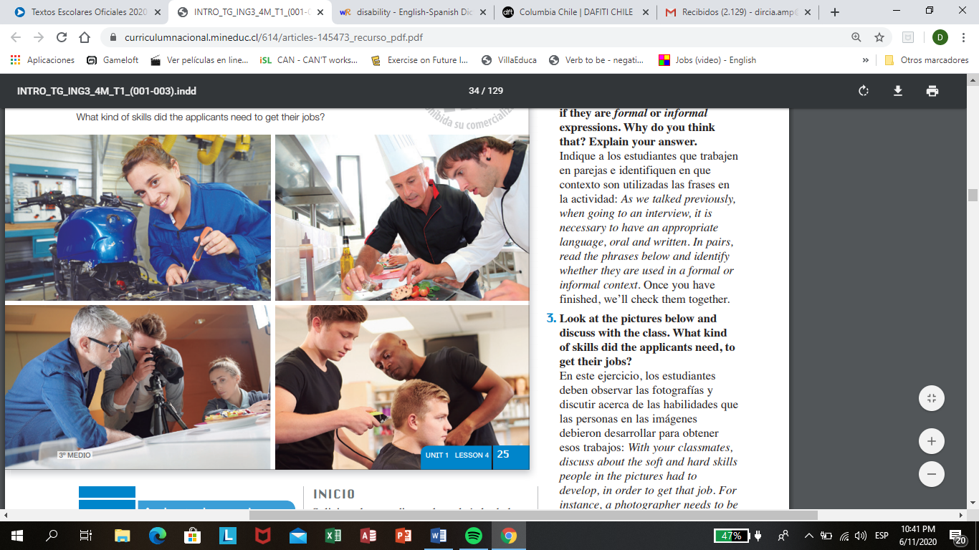

4

3

1

2

1. …………………………………………………………………………………………
2. …………………………………………………………………………………………
3. ………………………………………………………………………………………….
4. ………………………………………………………………………………………….