|  |  |
| --- | --- |
| antorcha liceo | **Liceo República Argentina**  Coyhaique  English Worksheets  Teacher Dircia Ampuero |

English worksheet

**1º medio**

Full Name: …………………………………… Grade: ………………………

**Objective**: read and analyze information in job advertisements.

use strategies to identify specific information in the texts.

Instruction:

Complete the sentences in the worksheet and then send me an email, with the answers in color red or answer in your copybook and send me a photo, ampuero.catalan.dircia@gmail.com

**Delivery date, June, Tuesday 7th 2020.**

1. 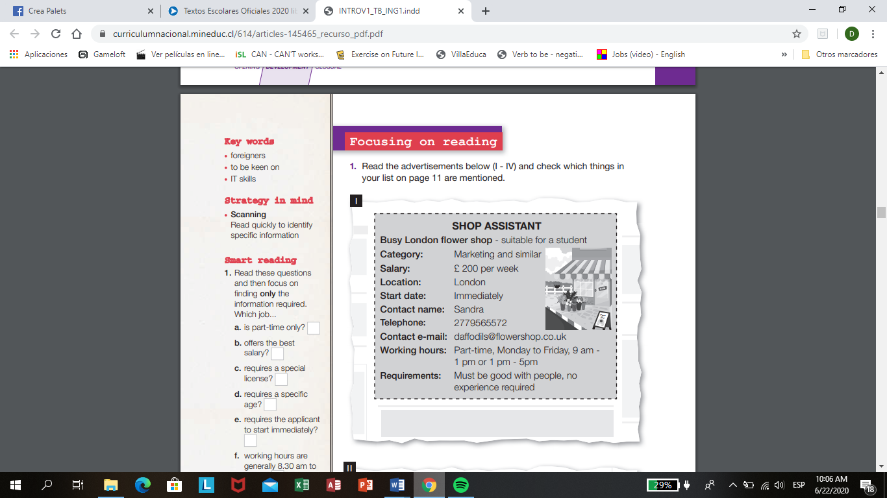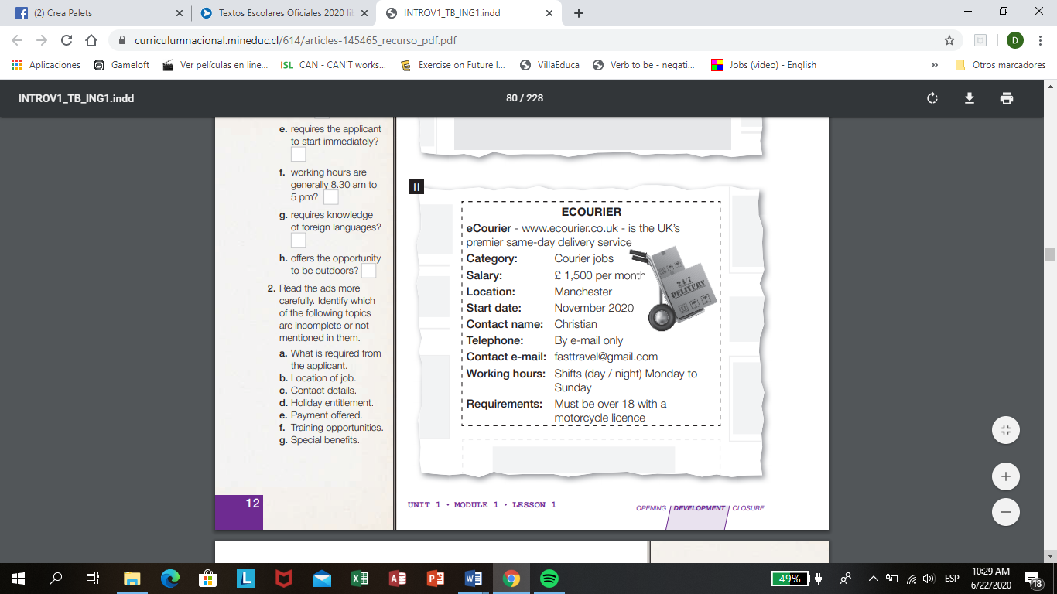Read the advertisement and answer the questions.

**II**

**I**

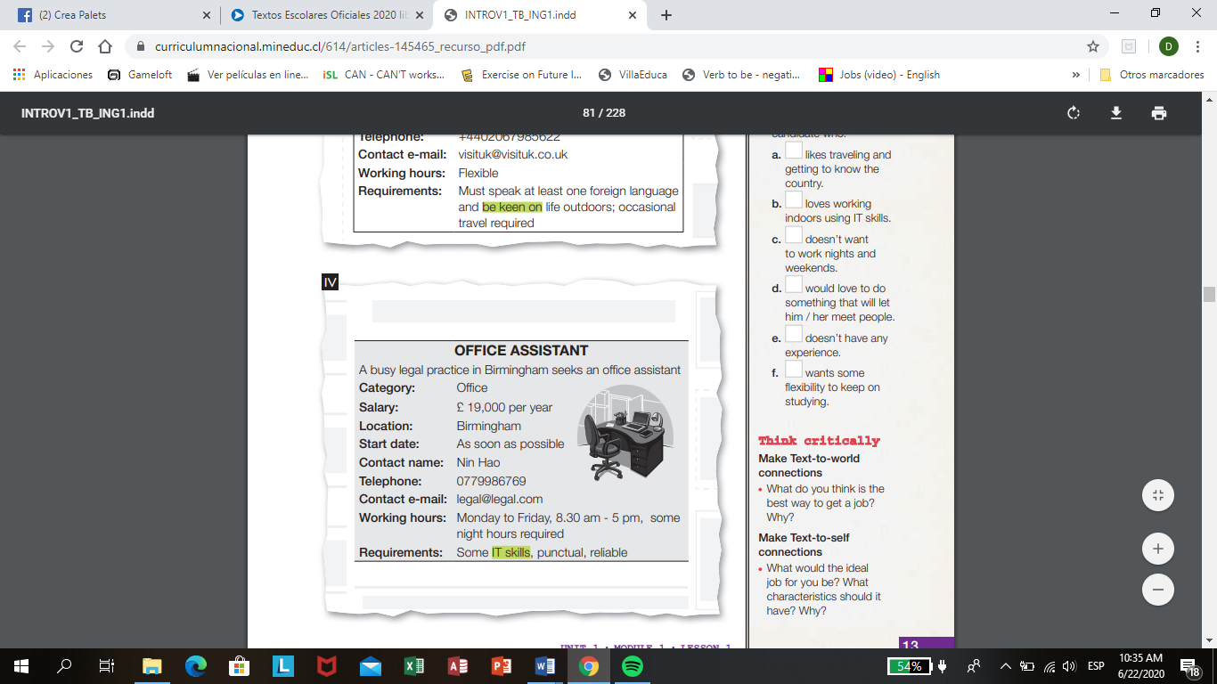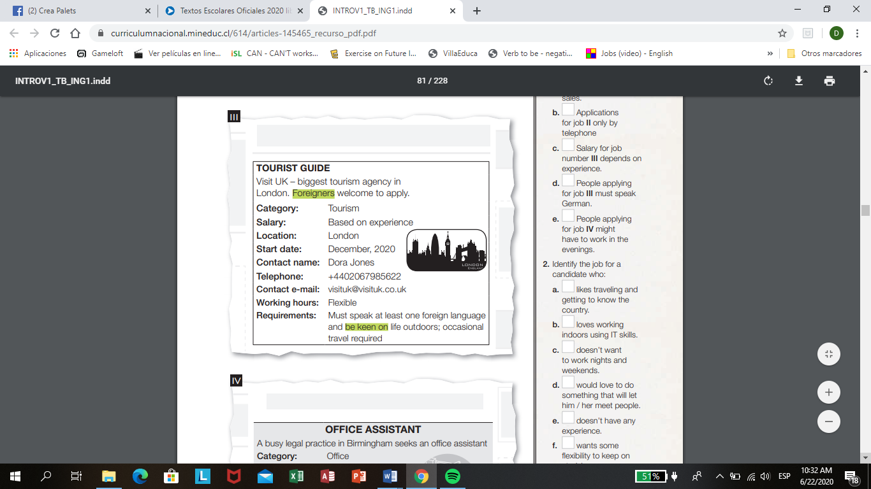

**IV**

**III**

**Read these questions and then focus on finding only the information required. (I – IV)**

a. is part-time only? b. offers the best salary c. requires a special license?

d. requires a specific age? e. requires the applicant to start immediately?

f. working hours are generally 8.30 am to 5 pm?

g. requires knowledge of foreign languages?

h. offers the opportunity to be outdoors?

1. **Read the advertisement more carefully. Identify which of the following topics are incomplete or not mentioned in them. Put a √**

a. What is required from the applicant.

b. Location of job.

c. Contact details.

d. Holiday entitlement.

e. Payment offered.

f. Training opportunities.

g. Special benefits.

1. **True or False?**

a. Job **I** involves sales.

b. Applications for job **II** only by telephone

c. Salary for job number **III** depends on experience.

d. People applying for job **III** must speak German.

e. People applying for job **IV** might have to work in the evenings.

1. **Identify the job for a candidate who:**

a. likes traveling and getting to know the country.

b. loves working indoors using IT skills.

c. doesn’t want to work nights and weekends.

d. would love to do something that will let him / her meet people.

e. doesn’t have any experience.

f. wants some flexibility to keep on studying.

**5. Answer the questions.**

a. What are the name of the jobs in the advertisement?

………………………………………………………………………..

b. Which are the cities mention in the advertisement?

………………………………………………………………………...

c. What are the salaries mention in the advertisements?

…………………………………………………………………………

d. Which are the categories of the jobs advertisements?

…………………………………………………………………………