|  |  |
| --- | --- |
| antorcha liceo | **Liceo República Argentina**  Coyhaique  English Worksheets  Teacher Dircia Ampuero |
|  |  |

English worksheet 3º medio Mecánica

Full name: ………………………………………………………………

Objective: Identify different traffic signs, according to the pictures.

Find specific information.

Instruction:

You can send me the worksheet to my email [ampuero.catalan.dircia@gmail.com](mailto:ampuero.catalan.dircia@gmail.com) or take a picture.

Also you can return it to the Liceo.

Delivery date; May, Tuesday 26th

1. Look at the traffic signs and write the correct number for each one.

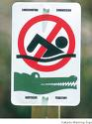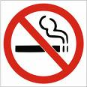

**2**

**1**

No swimming: Crocodiles!

No U-turn

Slippery road

No parking

Traffic lights ahead

Maximum speed 60 kph

Danger: Poison

Radioactivity

No flammable goods allowed

No dogs allowed

Don’t feed the animals

No spitting

Hospital

No eating or drinking

Kangaroo warning

Mobile phones not allowed

Danger: Falling rocks

No smoking

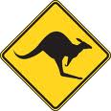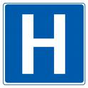

**4**

**3**

**7**

**8**

**6**

**5**

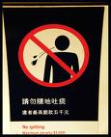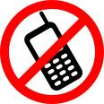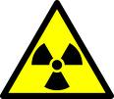

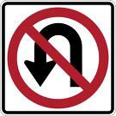

**10**

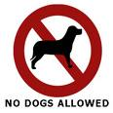

**9**

**11**

**12**

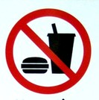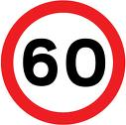

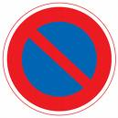

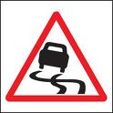

**13**

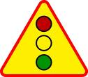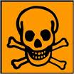

**15**

**14**

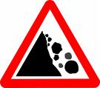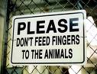

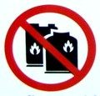

**18**

**17**

**16**

1. **Write the name for each traffic sign (more than one word possible)**

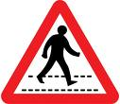

1

1. 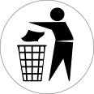…………………………………………………………………………………

2

1. 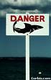…………………………………………………………………………………
2. …………………………………………………………………………………

3

**3. Fill in the gaps with the must (deberías) /mustn´t (no deberías) and the following words**; give away / stop here / turn left / go straight / walk here / turn right /

park here / be careful

***You must stop here: Tú debes parar aquí.***

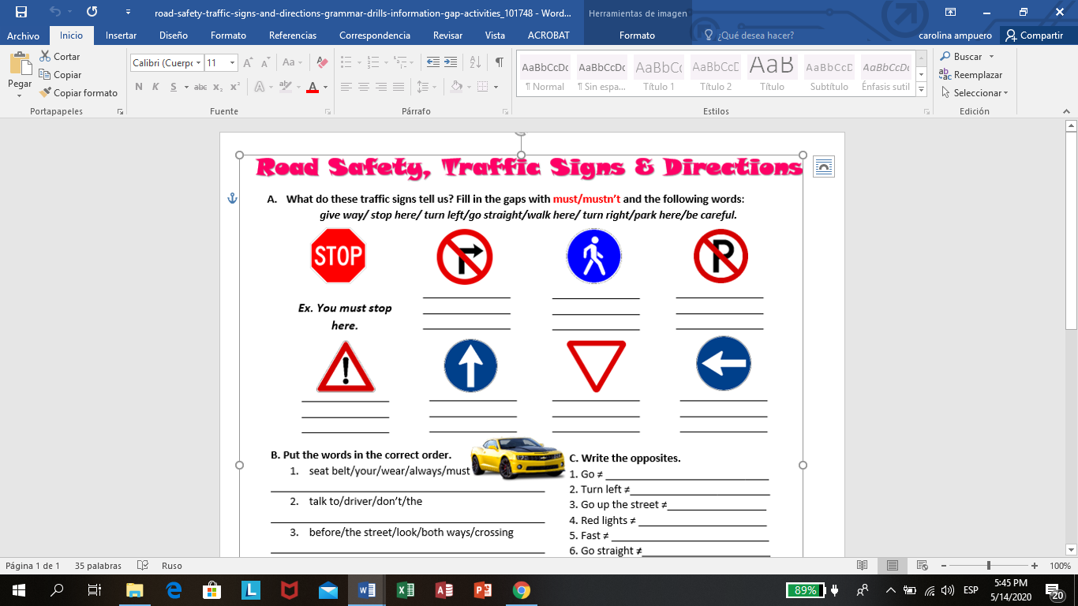

**4. Write the meaning for traffic signs.**

Stop here: give away: turn left: go straight:

Walk here: turn right: park here: be careful:

Traffic lights: speed limit: school crossing:

**5. Write the traffic signs that you can see in the pictures.**

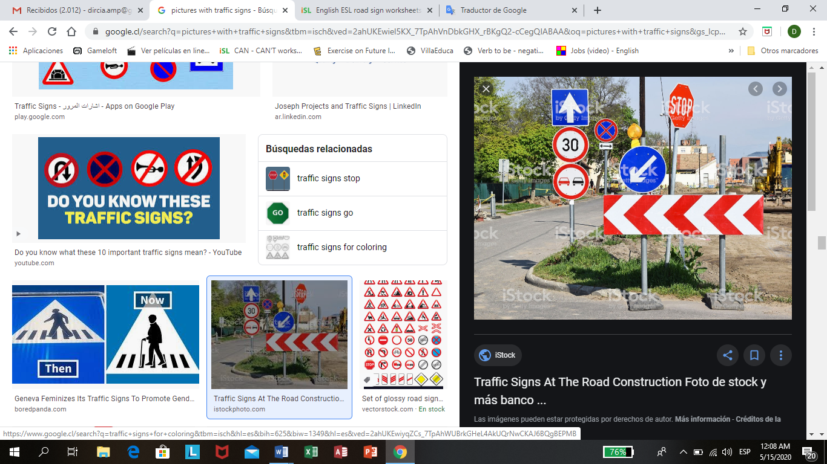

……………………………………………..

……………………………………………..

…………………………………………….

……………………………………………..

……………………………………………..

……………………………………………..

………………………………………………

**6. Use “must” or “mustn’t” to tell me what these signs mean. Join the correct sign to the sentence.**

**http://www.alltravelfrance.com/Common/images/CarRental/info_06.gif**

You ______________ smoke here.

[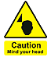](cgi/products.pl?sign=Caution%20Mind%20your%20Head)[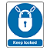](cgi/products.pl?sign=Keep%20locked%20sign)[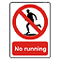](cgi/products.pl?sign=No%20running%20sign)[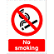](cgi/products.pl?sign=no%20smoking)http://www.alltravelfrance.com/Common/images/CarRental/info_11.gifhttp://www.alltravelfrance.com/Common/images/CarRental/info_15.gifhttp://www.alltravelfrance.com/Common/images/CarRental/info_10.gif

You _______________ go down this road

You _____________ keep this door locked.

You ___________ stop.

You __________________ walk.

You ________________ overtake.

You _____________ be careful.

You _______________ drive faster than 50 kph