|  |  |
| --- | --- |
| antorcha liceo | **Liceo República Argentina**  Coyhaique  English Worksheets  Teacher Dircia Ampuero |

English worksheet

4º medio Administración

Full Name: …………………………………… Grade: ………………………

Objective: Identify specific information through a simple text.

Recognize different hobbies.

Instruction:

Complete the sentences in the worksheet and then send me an email, with the answers in color red or answer in your copybook and send me a photo,

ampuero.catalan.dircia@gmail.com

**Delivery date, May, Friday 29th 2020.**

1. Read a simple text and answer the sentences.

Can: puedo Can´t: no puedo

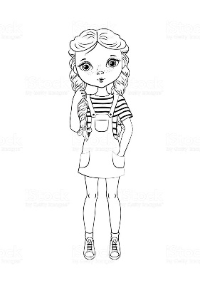This is May. She’s ten years old. She’s tall and thin. She’s got long brown hair. She’s got brown eyes.

She can sing and dance. She can’t swim.

Every Monday, May reads Chinese books with her friends. Every Tuesday, she rides a bike to school. On Wednesdays, she plays music at school. On Thursdays, she sings English songs with her friends. Every Friday, she cooks eggs at home.

* What is the name of the girl? …………………………………….
* What are her physical characteristics? …………………………………………………………………………………………………………………………………………………………………………
* What does she do on Mondays? …………………………………………………………………………………….
* What does she do on Fridays? ……………………………………………..

1. Write the correct day according to her activities.

|  |  |  |  |  |
| --- | --- | --- | --- | --- |
|  |  |  |  |  |
| __________ | __________ | __________ | __________ | __________ |

1. Answer True (T) or False (F).

1. May reads Chinese books. _________

2. May rides a bike to school on Fridays. _________

3. She plays music at home. _________

4. She plays music at school on Wednesdays. _________

5. She cooks pizza. _________

1. Answer with short answers, Yes or No.
2. Does May ride a bike on Mondays?

……………………………………………………….

1. Does May sing English songs?

……………………………………………………….

1. Does May cook on Fridays?

……………………………………………………….

1. Does she play music on Wednesdays?

……………………………………………………….

1. Does May read Chinese books on Tuesdays?

……………………………………………………….