|  |  |
| --- | --- |
| antorcha liceo | **Liceo República Argentina**  Coyhaique  English Worksheets  Teacher Dircia Ampuero |

English worksheet

3º medio Conectividad

Full Name: …………………………………… Grade: ………………………

Objective: Recognize and identify parts of the computers.

Instruction:

Complete the sentences in the worksheet and then send me an email, with the answers in color red or answer in your copybook and send me a photo,

ampuero.catalan.dircia@gmail.com

**Delivery date, May, Tuesday 26th 2020.**

1. How many parts of the computer you can label using the following key words.

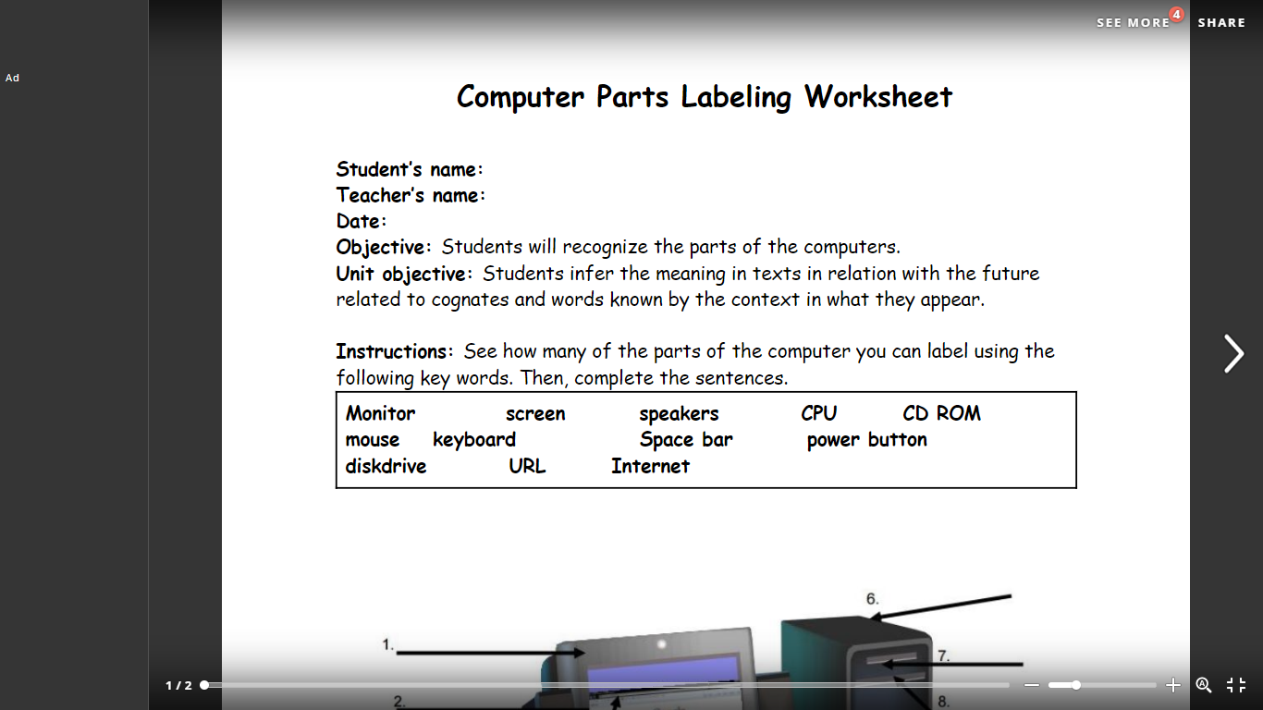

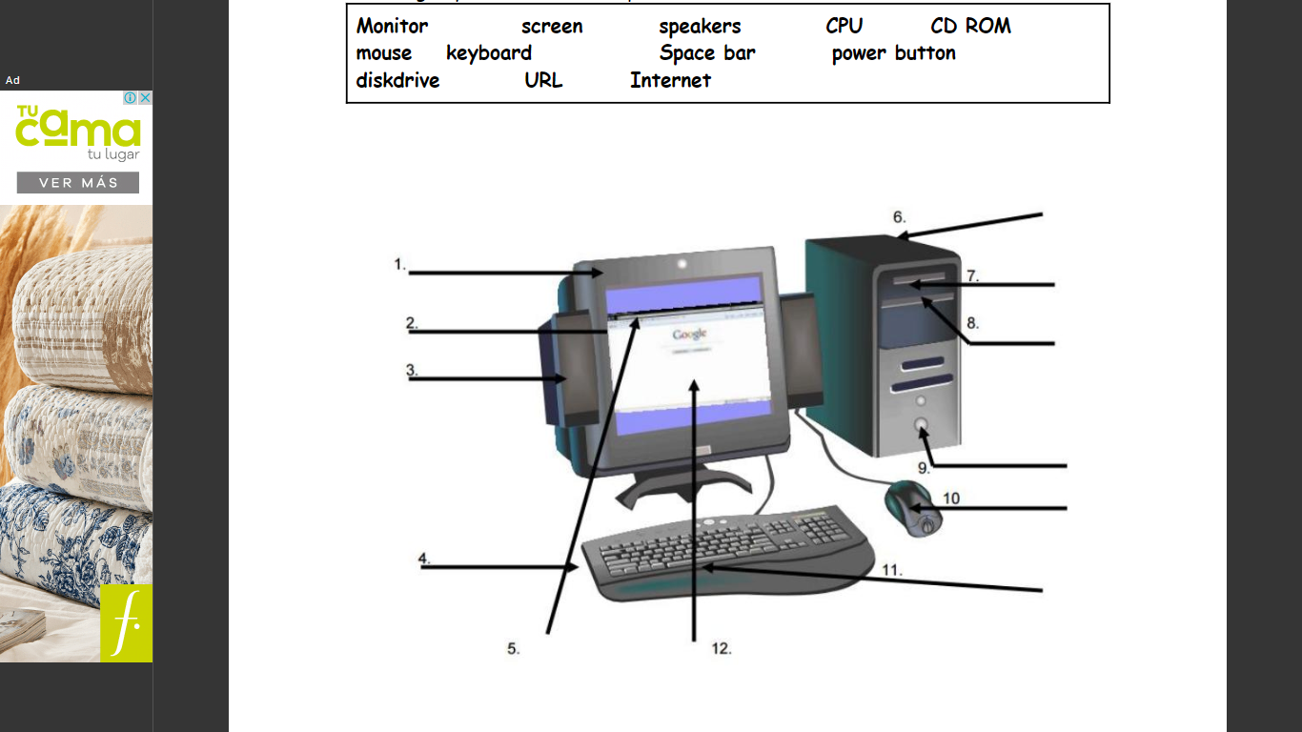

1. Translate the reading “What is a computer” into Spanish.

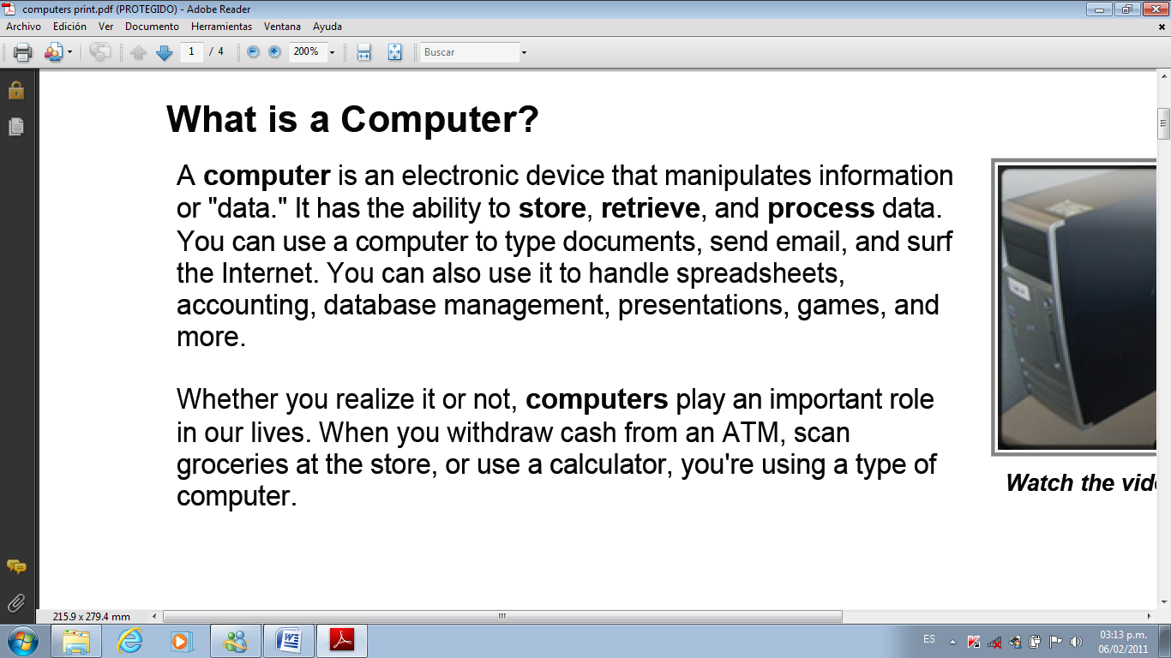

…………………………………………………………………………………………………………………………………………………………………………………………………………………………………………………………………………………………………………………………………………………………………………………………………………………………………………………………………………………………………………………………………………………………………………………………………………………………………………………………………………………………………………………………………………………………………………………………………………………………………………………………………………………………………………………………………………………………………………………………………………………………………………………………………………………………………………………………………………………………………………………………………………………………………………………………………………………………………………………………………………………………………………………………………………………………………………………………………………………………………………………………………………………………………………………………………………

1. **Mixed-up sentences: join 1-5 with a-e to form sentences.**

Vocabulary attach: adjuntar – corrupt: alterado – hard drive: disco duro

download: descargar – data: datos – run: operar, ejecutar

1. A virus can corrupt…
2. From time to time you should run…
3. My brother is an internet freak. He…
4. Can you help me attach…
5. I need to download…
6. … a file to this message?
7. … the hard drive of your computer, making all your data not available.
8. … spends hours surfing the net.
9. … a program for drawing maps.
10. … scandisk to keep your computer healthy.
11. **Complete the sentences with the correct information.**

What is this part of the computer system called? ________________________.

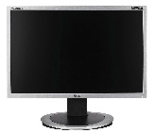a) Monitor

b) Keyboard

c) Mouse

d) CPU

2. True or False, you can hear sounds from the computer using speakers.

a) True

b) False

3. Which one of the following parts is an input part? _________________

a) Speaker

b) Monitor

c) Keyboard

d) CPU

4. This part holds the "brain" of the computer. It is called the __________.

a)Mouse

b)Keyboard

c) CPU

5. Is a printer an input device or an output device? ____________________.

a) output

b) input