|  |  |
| --- | --- |
| antorcha liceo | **Liceo República Argentina**  Coyhaique  English Worksheets  Teacher Dircia Ampuero |

English worksheet

**4º medio mecánica**

Full Name: …………………………………… Grade: ………………………

**Objective**: to understand specific information about cars in written text through pictures and descriptions.

Instruction:

Complete the sentences in the worksheet and then send me an email, with the answers in color red or answer in your copybook and send me a photo, ampuero.catalan.dircia@gmail.com

**Delivery date, June, Friday 12th 2020.**

1. **Find the meaning in the dictionary.**

Windscreen: wiper:

Steering wheel: Mirror:

Trunk: Door:

Bonnet: bumper:

Tire: brake:

Lights:

Indicators lights:

Wheels:

Windows:

1. **Look at the picture and fill in the parts car shown at the photo.**

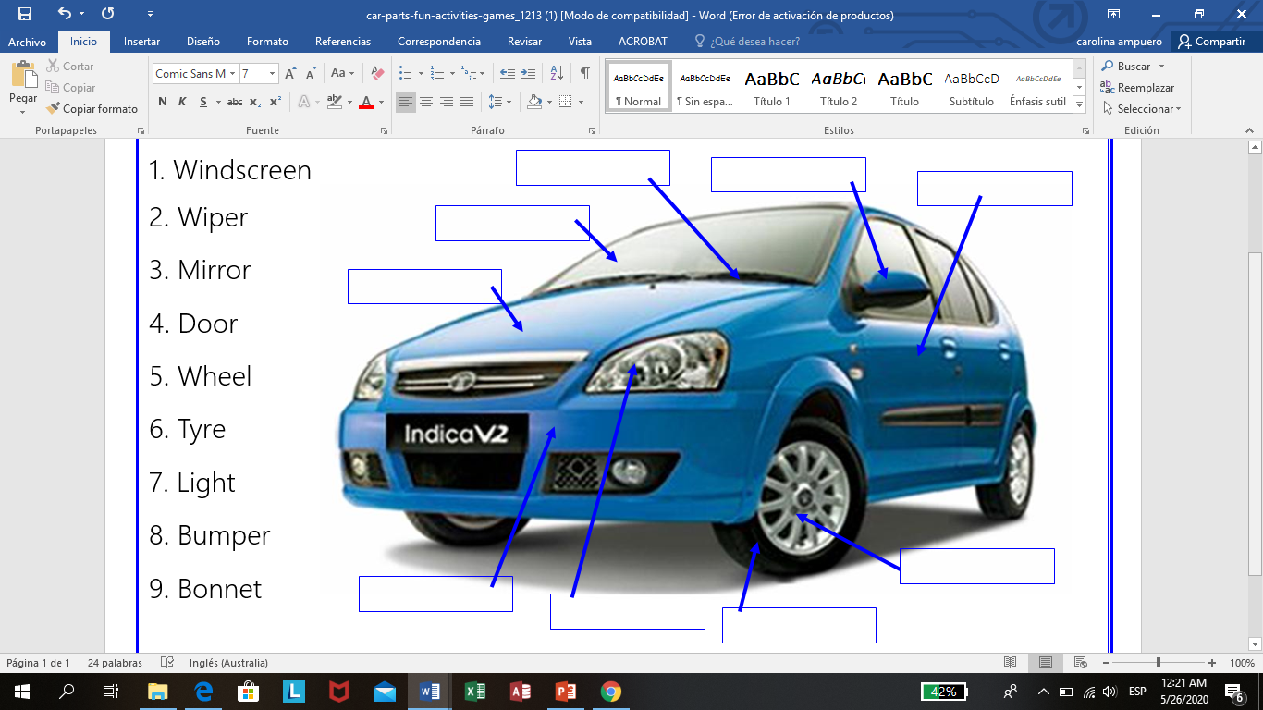

1. **Now try to find these words, all of them are parts of cars.**
2. **T R U N..K**  the place where you can put your bags.
3. B…………...T the part of a car which covers the engine.
4. T …………..S Michelin, Goodyear and Bridgestone make these.
5. L…………..S you need these when you drive at night.
6. I…………...........................S when you turn right or left you use these.
7. B ………………E these are very important. Unless you never want to stop.
8. W …………………S It´s nice to open these on a hot day.
9. S …………………………….L you hold it in your hand when you drive.
10. W…………………………..N you look through it when you drive.
11. **Complete the recommendations for driving a car, Using modals.**

Should: Deberías Shouldn´t: No deberías

1. You ………………….. talk by mobile phone while you are driving.
2. You ………………… take all your car documents.
3. You ………………… respect the traffic light, when it is red.
4. You ………………… drive a car drunk.
5. You …………………. drive with high speed.
6. You …………………. know the traffic rules.
7. Find the meaning for interior parts car.

steering wheel: speedometer: ignition key:

accelerator or gas pedal: seat belt:

brake: clutch: handbrake:

gear stick:

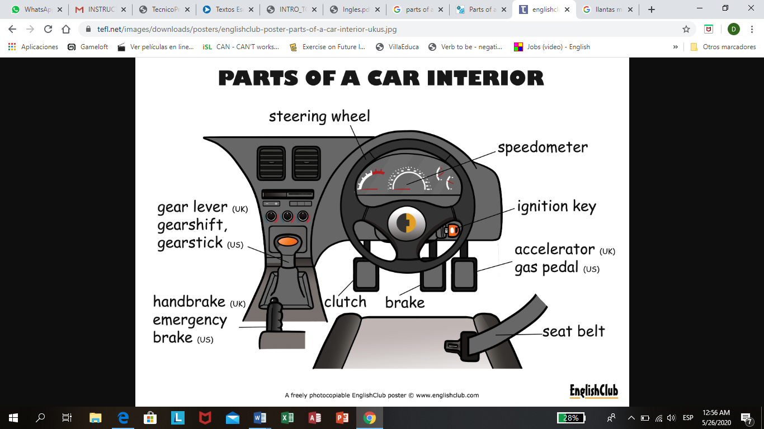

1. **Now classify the parts of the car into internal and external parts.**

Wheels handbreak tyre bumper trunk brake seatbealt lights

Wiper horn bonnet clutch ignition

|  |  |
| --- | --- |
| INTERNAL PARTS | EXTERNAL PARTS |
|  |  |
|  |  |
|  |  |
|  |  |
|  |  |
|  |  |
|  |  |