|  |  |
| --- | --- |
| antorcha liceo | **Liceo República Argentina**  Coyhaique  English Worksheets  Teacher Dircia Ampuero |

English worksheet

2º medio

Full Name: …………………………………… Grade: ………………………

**Objective**: To demonstrate comprehension of general ideas and explicit information in written texts about globalization and communication.

Instruction:

Complete the sentences in the worksheet and then send me an email, with the answers in color red or answer in your copybook and send me a photo,

ampuero.catalan.dircia@gmail.com

**Delivery date, June, Tuesday 9th 2020.**

Pay attention to the description below, and complete the activities.

Global city fundamentally means taking into account its financial, administrative, scientific, educational and informational activities.

Ciudad global significa fundamentalmente tener en cuenta sus actividades financieras, administrativas, científicas, educacionales e informacionales.

1. **Choose and write five ítems from the box that you think are the most important to be a global city.**
2. 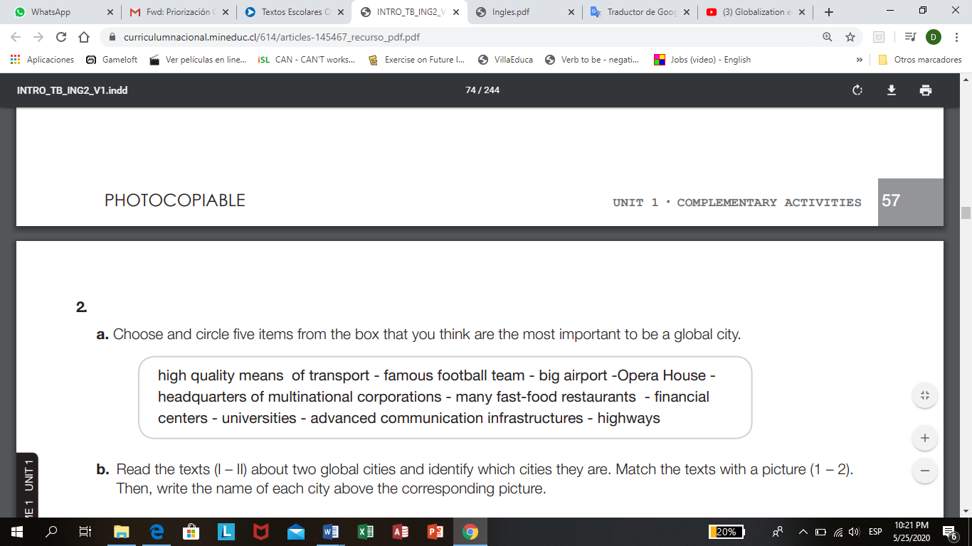………………………………………………………………
3. ………………………………………………………………
4. ………………………………………………………………
5. ………………………………………………………………
6. ………………………………………………………………
7. **Read the text (I – II ) about two global cities and identify wich cities they are. Match the texts with a picture (1-2), then write the name of each city above the corresponding picture**.

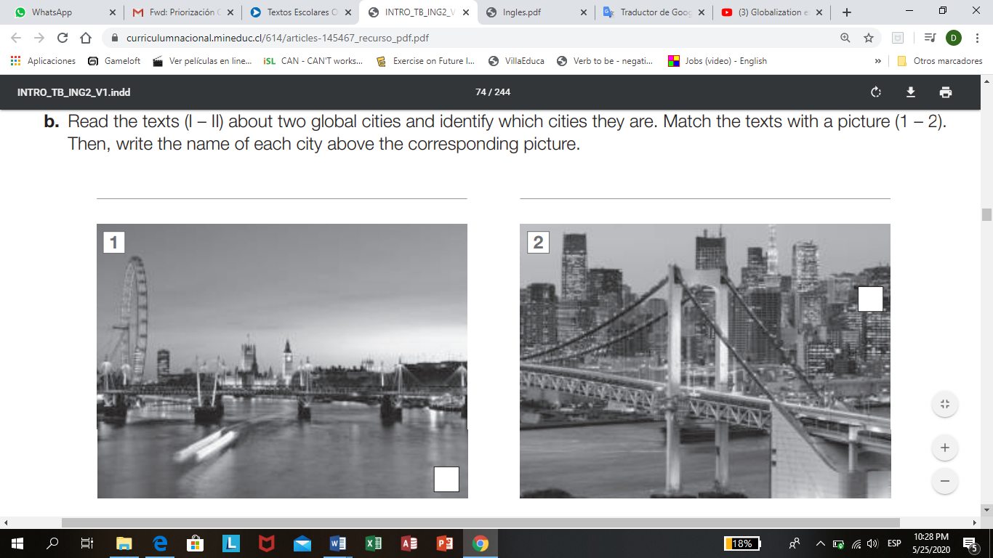______________________________________ _________________________________

New York – Germany – London - Tokyo

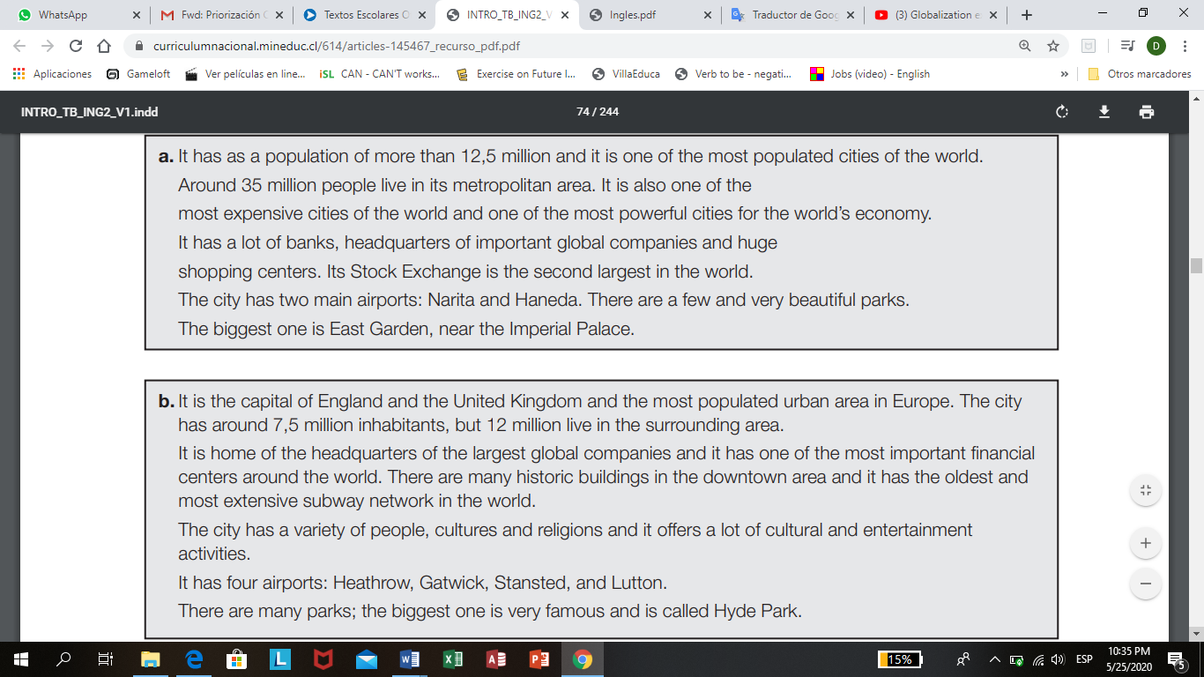Complete the file with the correct information.



|  |  |
| --- | --- |
| Name of the city |  |
| Population |  |
| Airports |  |
| Parks |  |

|  |  |
| --- | --- |
| Name of the city |  |
| Population |  |
| Airports |  |
| Parks |  |
| Means of Transport |  |