|  |  |
| --- | --- |
| antorcha liceo | **Liceo República Argentina**  Coyhaique  English Worksheets  Teacher Dircia Ampuero |

English worksheet

**4ºmedio Administración**

Full Name: …………………………………… Grade: ………………………

**Objective**: Express ideas about a first job in written text and express opinions.

Instruction:

Complete the sentences in the worksheet and then send me an email, with the answers in color red or answer in your copybook and send me a photo,

ampuero.catalan.dircia@gmail.com

**Delivery date, June, Friday 12th 2020.**

1. 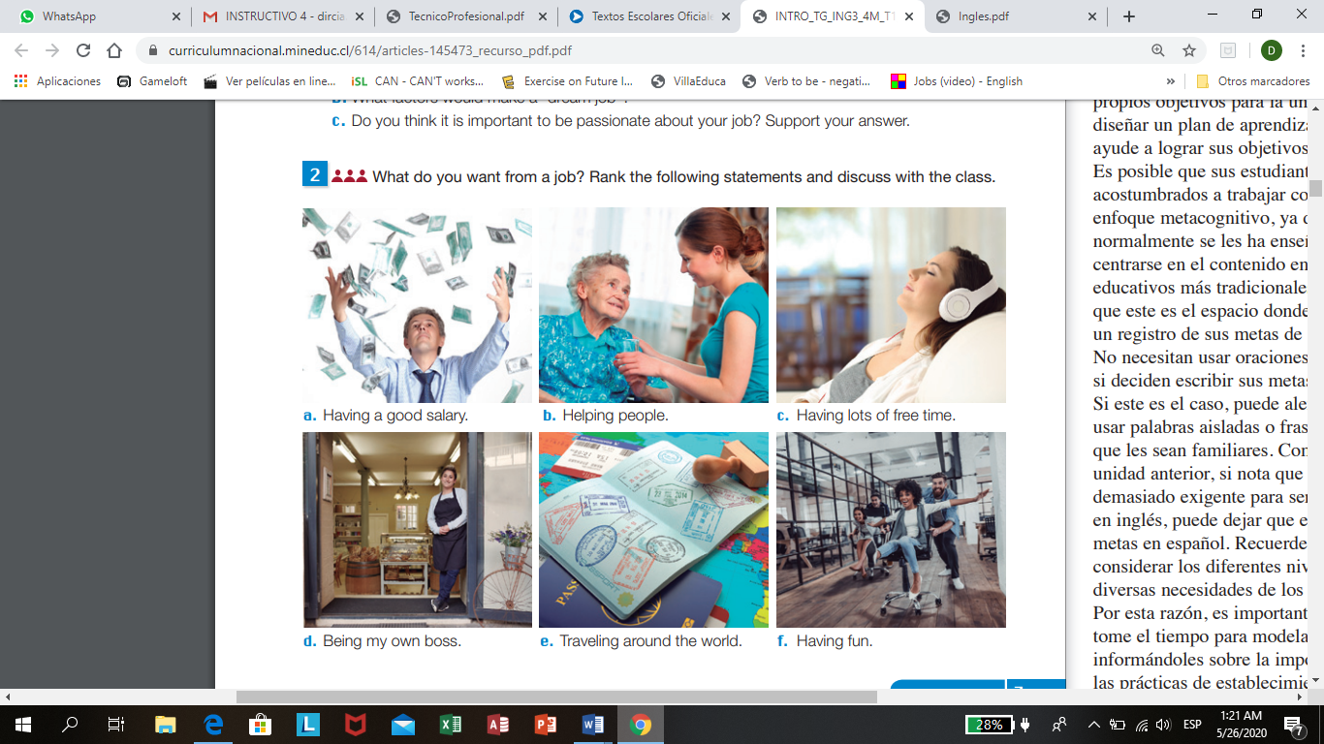What do you want from a job? Rank the following statements and write the meaning in Spanish next to the list.
2. ………………………………………. ……………………………………..
3. ………………………………………. ……………………………………..
4. ………………………………………. ……………………………………..
5. ………………………………………. ……………………………………..
6. ………………………………………. ……………………………………..
7. ………………………………………. ……………………………………..

b.

1. What sectors do these jobs belong to? Classify them.

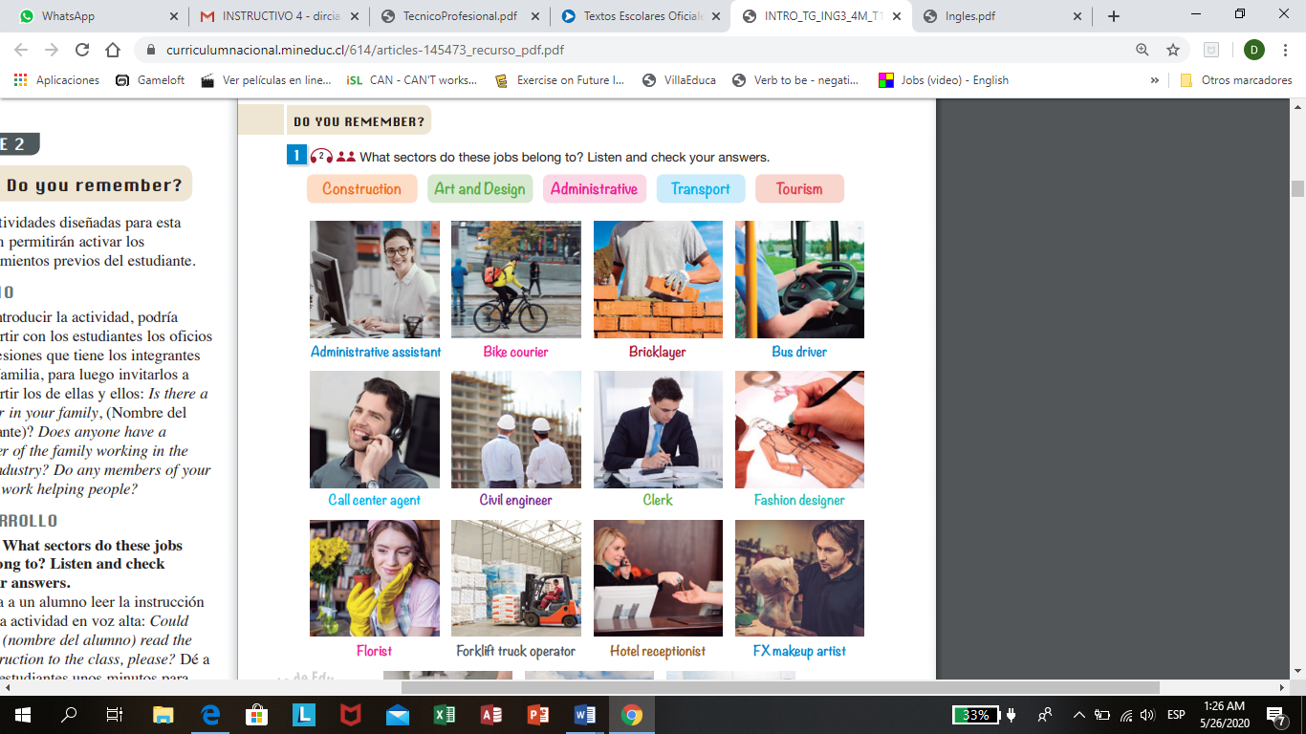

|  |  |  |  |  |
| --- | --- | --- | --- | --- |
| CONSTRUCTION | ART AND DESIGN | ADMINISTRATIVE | TRANSPORT | TOURISM |
|  |  |  |  |  |
|  |  |  |  |  |
|  |  |  |  |  |
|  |  |  |  |  |
|  |  |  |  |  |
|  |  |  |  |  |

1. Find the meaning for each job.

Florist: Hotel receptionist: Make up artist:

Forklift truck operator: call center agent:

Civil engineer: Clerk: Fashion designer:

Administrative assistant: Bike courier:

Bricklayer: Bus driver:

1. Look at the pictures and match them with the description.

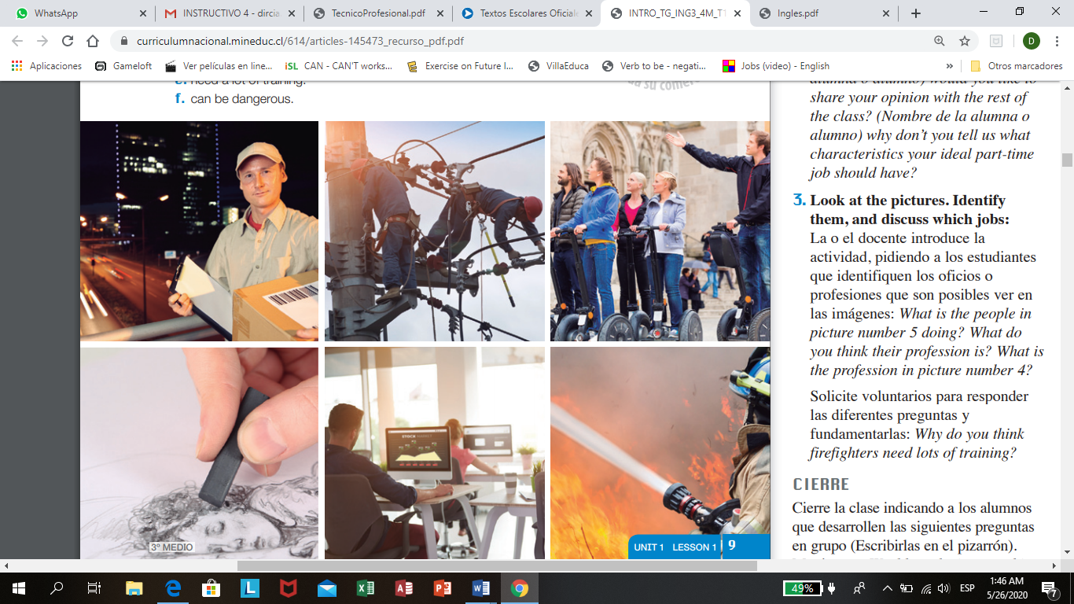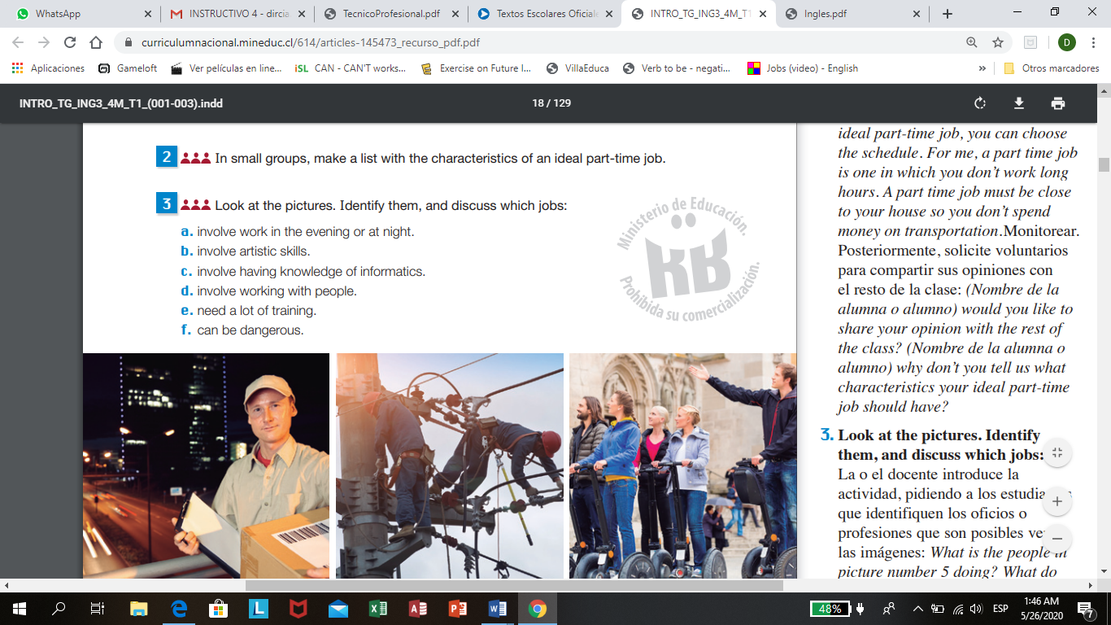

1. **Read the description and answer the question.**

**Part time job**; is a form of employment that carries fewer hours per week than a full time job. They work in shifts. Workers are considered to be part time if they commonly work fewer than 30 hours per week.

( Es una forma de empleo que conlleva menos horas por semanas que un trabajo de tiempo complete. Se trabaja por turnos, además son considerados trabajadores de medio tiempo si es que se trabajan menos de 30 horas a la semana.)

According to the description about part time job means;

What kind of part time job do you think you can do with your skills? Skill: habilidad

…………………………………………………………………………………….

Did any member of your family or a friend ever have a part time job? Which one?

…………………………………………………………………………………….

Would your parents allow you to work part time?

…………………………………………………………………………………….