|  |  |
| --- | --- |
| antorcha liceo | **Liceo República Argentina**  Coyhaique  English Worksheets  Teacher Dircia Ampuero |

English worksheet

**3º medio Conectividad**

Full Name: …………………………………… Grade: ………………………

**Objective**: Read and understand in different written text related to vocational interest. Recognize different computers parts.

Instruction:

Complete the sentences in the worksheet and then send me an email, with the answers in color red or answer in your copybook and send me a photo,

ampuero.catalan.dircia@gmail.com

**Delivery date, June, Friday 12th 2020.**

1. 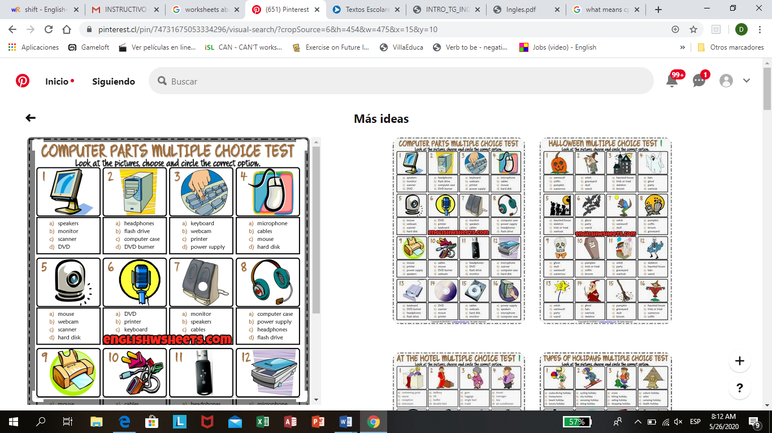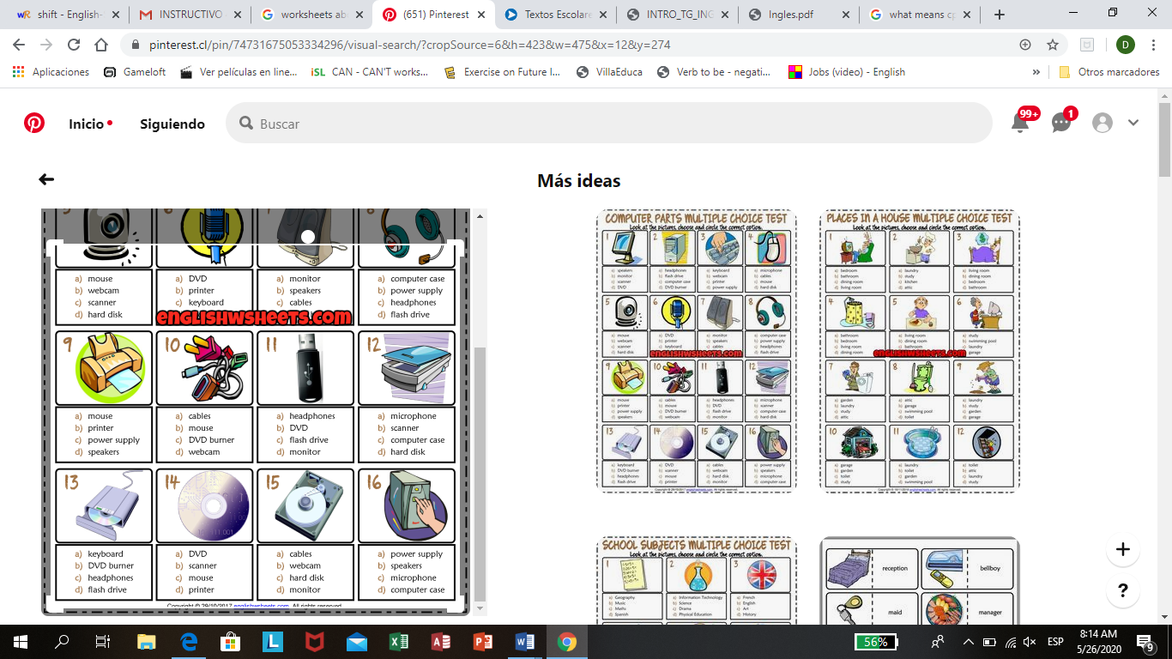Choose the correct alternative.

|  |  |
| --- | --- |
| antorcha liceo |  |

1. Find ten technical things in the word search.

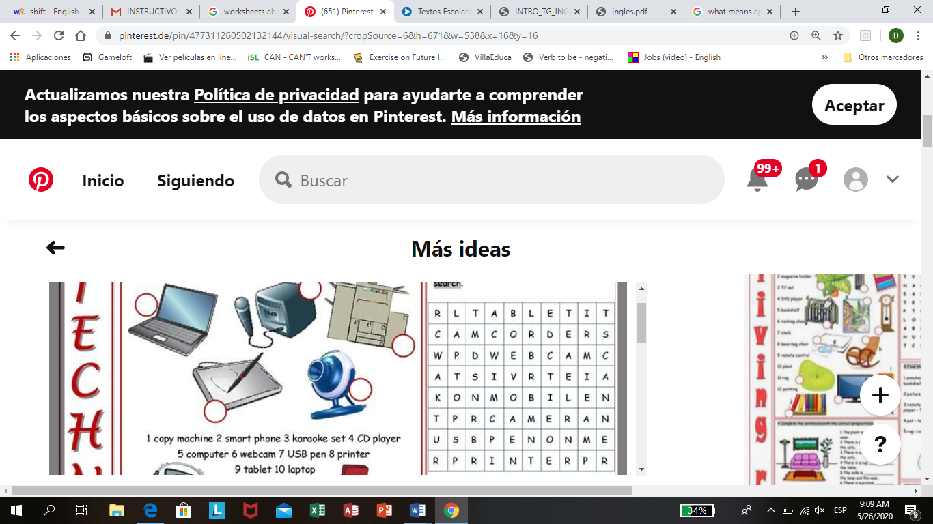

1…………………………………..

2…………………………………..

3…………………………………..

4…………………………………..

5…………………………………..

6…………………………………..

7…………………………………..

8…………………………………..

9…………………………………..

10…………………………………

1. Write True or Falso.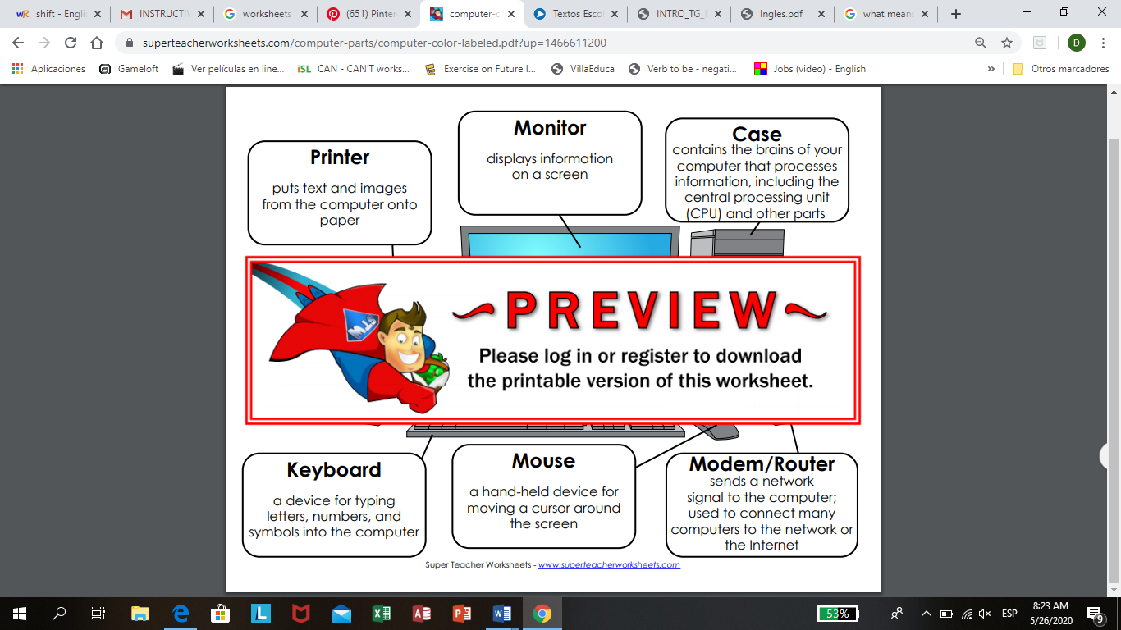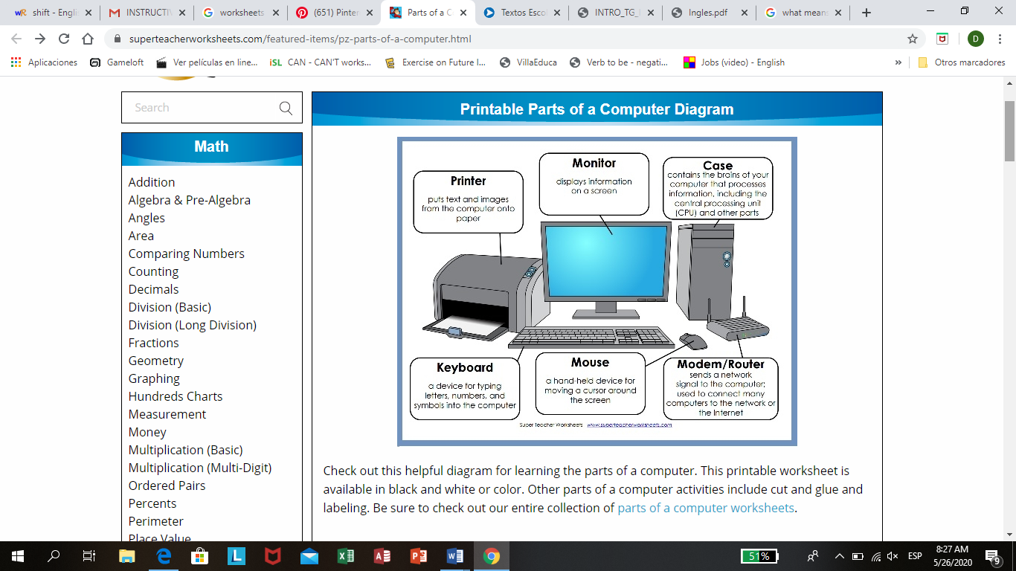

………………. A mouse is device for typing letter and numbers.

………………. Monitor displays information on a screen.

………………. Speakers puts text and images from the computer onto paper.

………………. Mouse a hand held device for moving a cursor around the screen.

1. 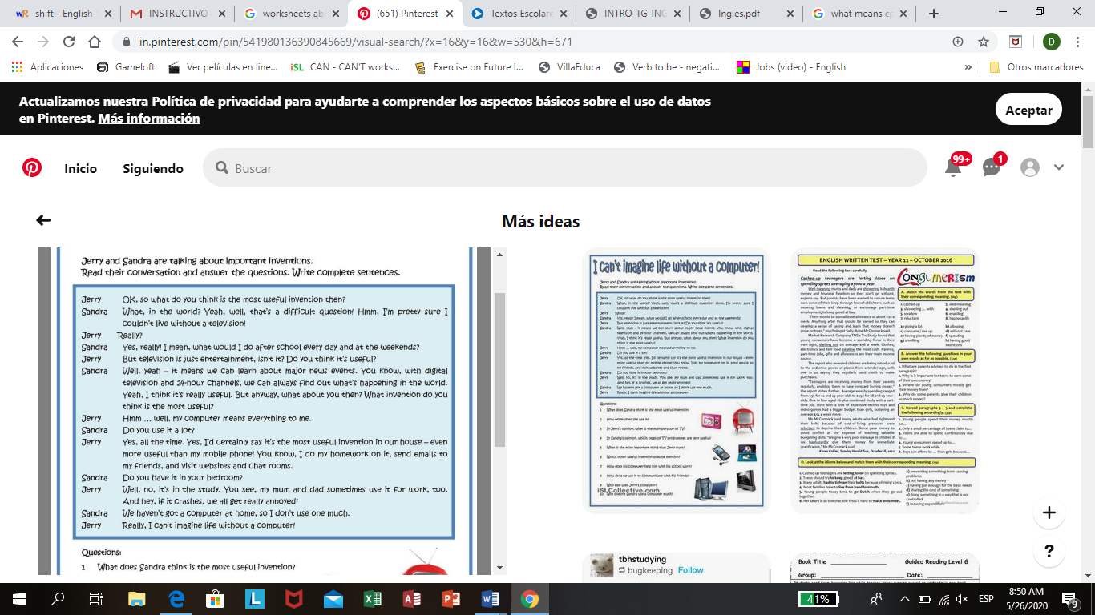Read the conversation and answer the following questions.
2. What does Sandra think is the most useful invention?......................................................
3. In Jerry´s opinion, what is the main purpose of TV?...........................................................
4. In Sandra´s opinion, which types of TV programs are very useful?..................................
5. What is the most important thing that Jerry owns?...............................................
6. Which other useful invention does he mention?...................................................
7. How does he use it to communicate with his friends?.........................................
8. Who else uses Jerry´s computer?.........................................