|  |  |
| --- | --- |
| antorcha liceo | **Liceo República Argentina**  Coyhaique  English Worksheets  Teacher Dircia Ampuero |

English worksheet

Name: ………………………………………………………………… Grade: ……………………….

Instruction:

Complete the worksheet in the computer, answer with color red, or do it in your copybook

take a photo and send me an email, [ampuero.catalan.dircia@gmail.com](mailto:ampuero.catalan.dircia@gmail.com)

Objective: Identify and recognize different feelings.

1. Find the meaning for each feelings in the dictionary.
2. excited: 6. tired:
3. happy: 7. sad:
4. angry: 8. in love:
5. nervous : 9. sick:
6. furious: 10. relaxed:
7. 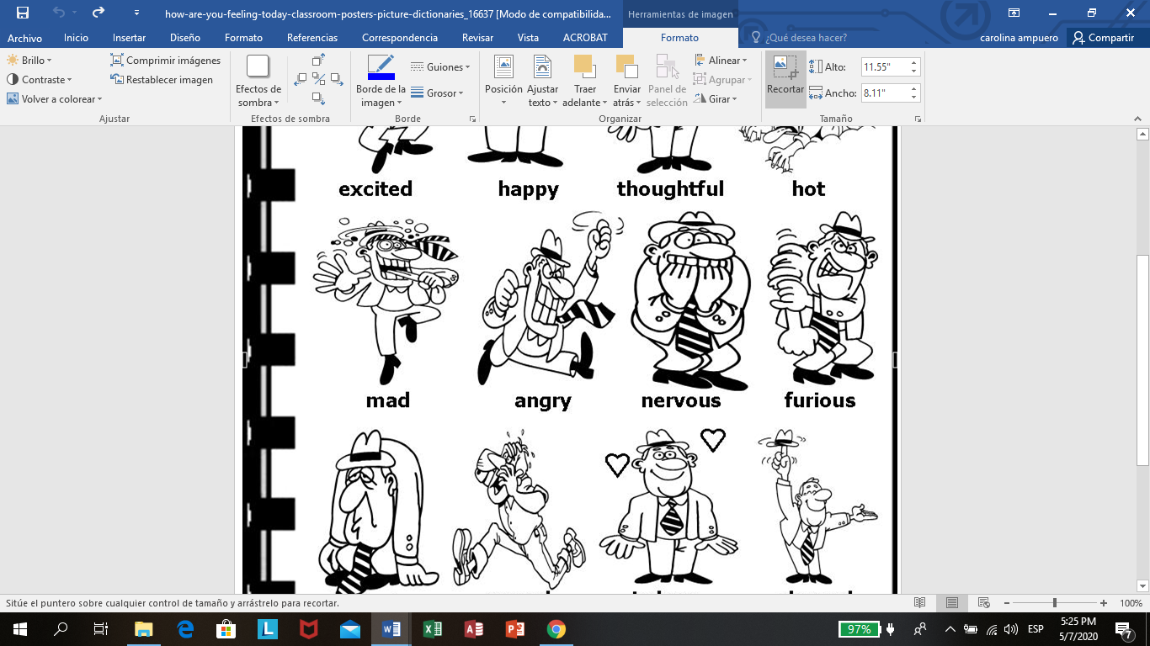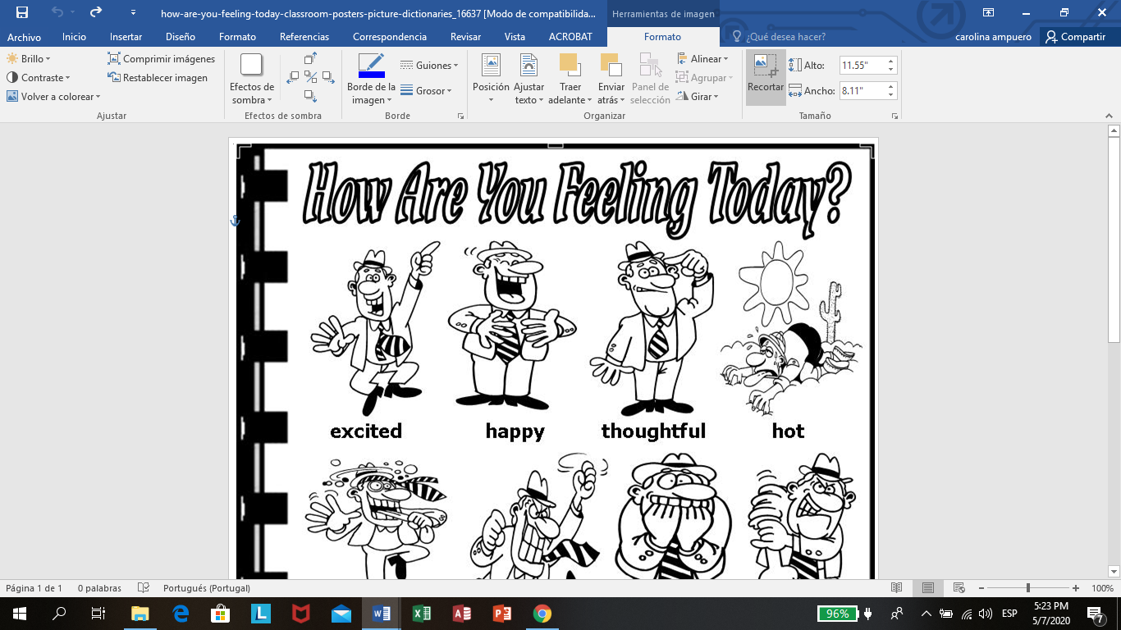Now you know the meaning, according to the pictures write the correct feeling for each picture.

…………………………….. ………………………………… ……………………………………….. …………………………….

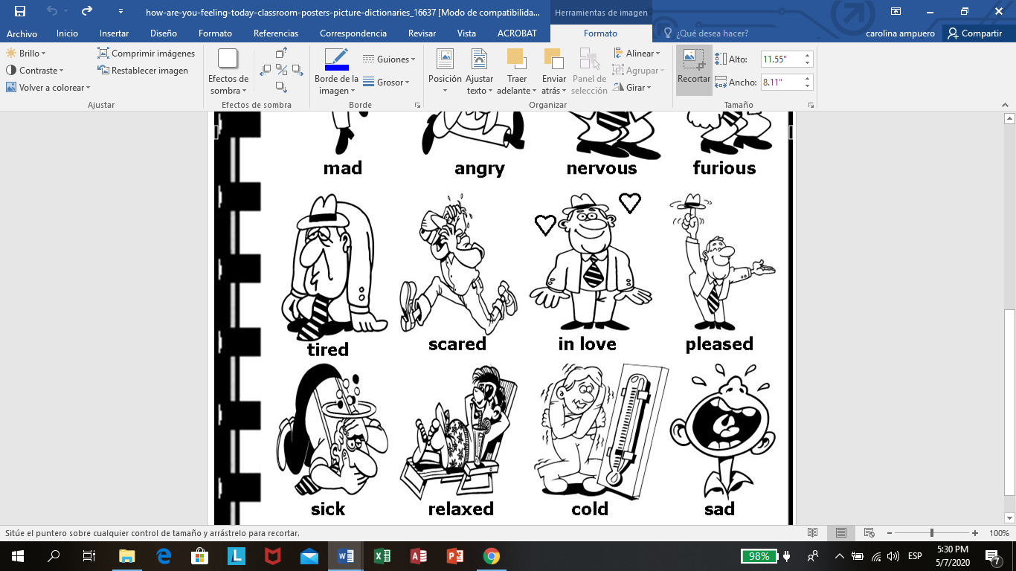

………………………………. ……………………………….. ………………………………….. …………………………………..

1. Now relax... Find the feelings write below and write the meaning.

**Feelings word search**

|  |  |  |  |  |  |  |  |  |  |  |  |  |  |  |  |  |  |
| --- | --- | --- | --- | --- | --- | --- | --- | --- | --- | --- | --- | --- | --- | --- | --- | --- | --- |
| **X** | **H** | **A** | **P** | **P** | **Y** | **B** | **W** | **A** | **B** | **L** | **M** | **L** | **H** | **K** | **A** | **Y** | **B** |
| **E** | **U** | **T** | **U** | **M** | **E** | **A** | **S** | **C** | **A** | **R** | **E** | **D** | **E** | **Q** | **R** | **N** | **O** |
| **N** | **N** | **S** | **A** | **D** | **Q** | **S** | **X** | **Z** | **D** | **Q** | **D** | **A** | **A** | **Z** | **B** | **E** | **R** |
| **E** | **G** | **E** | **F** | **T** | **H** | **I** | **R** | **S** | **T** | **Y** | **Z** | **S** | **L** | **M** | **L** | **F** | **E** |
| **R** | **R** | **D** | **H** | **R** | **F** | **C** | **H** | **L** | **A** | **X** | **A** | **H** | **T** | **I** | **R** | **E** | **D** |
| **G** | **Y** | **D** | **A** | **B** | **E** | **K** | **A** | **E** | **W** | **R** | **T** | **A** | **H** | **K** | **W** | **O** | **L** |
| **E** | **B** | **C** | **A** | **N** | **G** | **R** | **Y** | **E** | **J** | **K** | **A** | **M** | **Y** | **B** | **R** | **K** | **G** |
| **T** | **G** | **O** | **O** | **D** | **S** | **U** | **R** | **P** | **R** | **I** | **S** | **E** | **D** | **N** | **E** | **A** | **D** |
| **I** | **K** | **L** | **P** | **E** | **T** | **H** | **O** | **Y** | **W** | **I** | **N** | **D** | **E** | **T** | **H** | **Y** | **A** |
| **C** | **X** | **T** | **H** | **O** | **U** | **G** | **H** | **T** | **F** | **U** | **L** | **J** | **G** | **Y** | **F** | **N** | **L** |

Happy ………………….. Surprised …………………….

Sad ………………….. Scared …………………….

Energetic …………….. Bored …………………….

Angry ………………….. Tired ……………………..

Sick …………………. Ashamed ………………….

Thirsty …………………. Hungry …………………….

Sleepy …………………..

IV. Complete the sentences with the correct feeling.

HAPPY SCARED SICK SAD

Paul feels ..................... when he celebrates his birthday.

My mom feels ......................... when we saw horror movies.

I feel ................... I have to go to the doctor.

My dog had an accident, las week. I feel so .........................