|  |  |
| --- | --- |
| antorcha liceo | **Liceo República Argentina**  Coyhaique  English Worksheets  Teacher Dircia Ampuero |

English worksheet

1º medio

Full Name: …………………………………… Grade: ………………………

Objective: to demonstrate comprehension of general ideas and explicit information in written text, about jobs, professions and labour life.

Instruction:

Complete the sentences in the worksheet and then send me an email, with the answers in color red or answer in your copybook and send me a photo.

ampuero.catalan.dircia@gmail.com

**Delivery date, May, Tuesday 26th 2020.**

1. 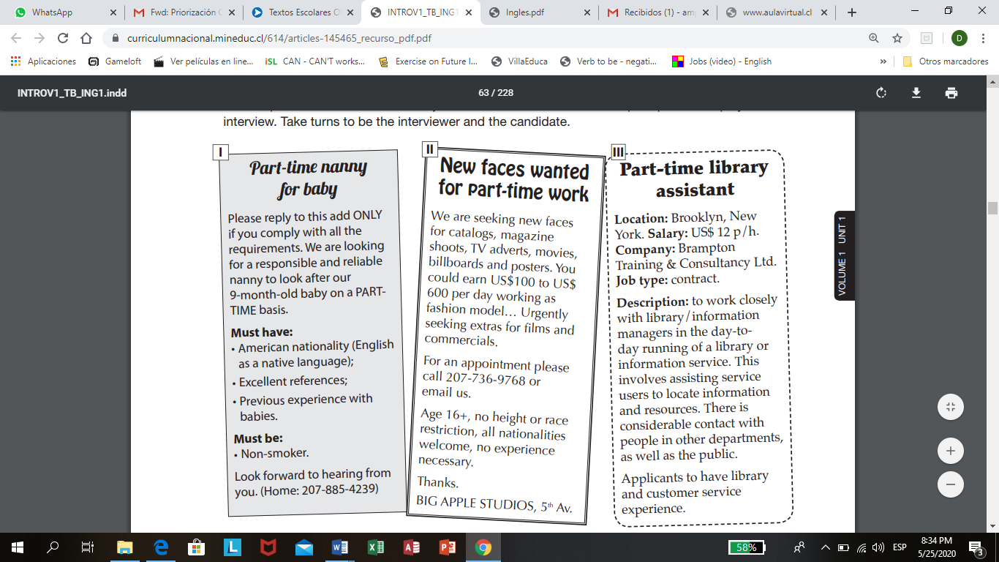**Read the jobs advertised below and answer the questions.**

**Choose the correct alternative.**

According to the first (1) job advertisement,

what are they looking for?

1. a secretary b) a chef c) a nanny d) a library assistant

What is the age of the baby?

1. one-year b) five months c) two years d) nine months

What are the requirements for nanny´s job?

1. Previous experience with babies b) no experience necessary

**Answer true or false.**

………….. for new faces wanted for part time you need experience.

………….. in this job you could earn US $ 2.000 per day.

………….. all nationalities are welcome.

………….. you can be working as fashion model, movies and commercials, etc.

**According to job number 3, complete with the missing information.**

Location:

Job type:

Company:

1. 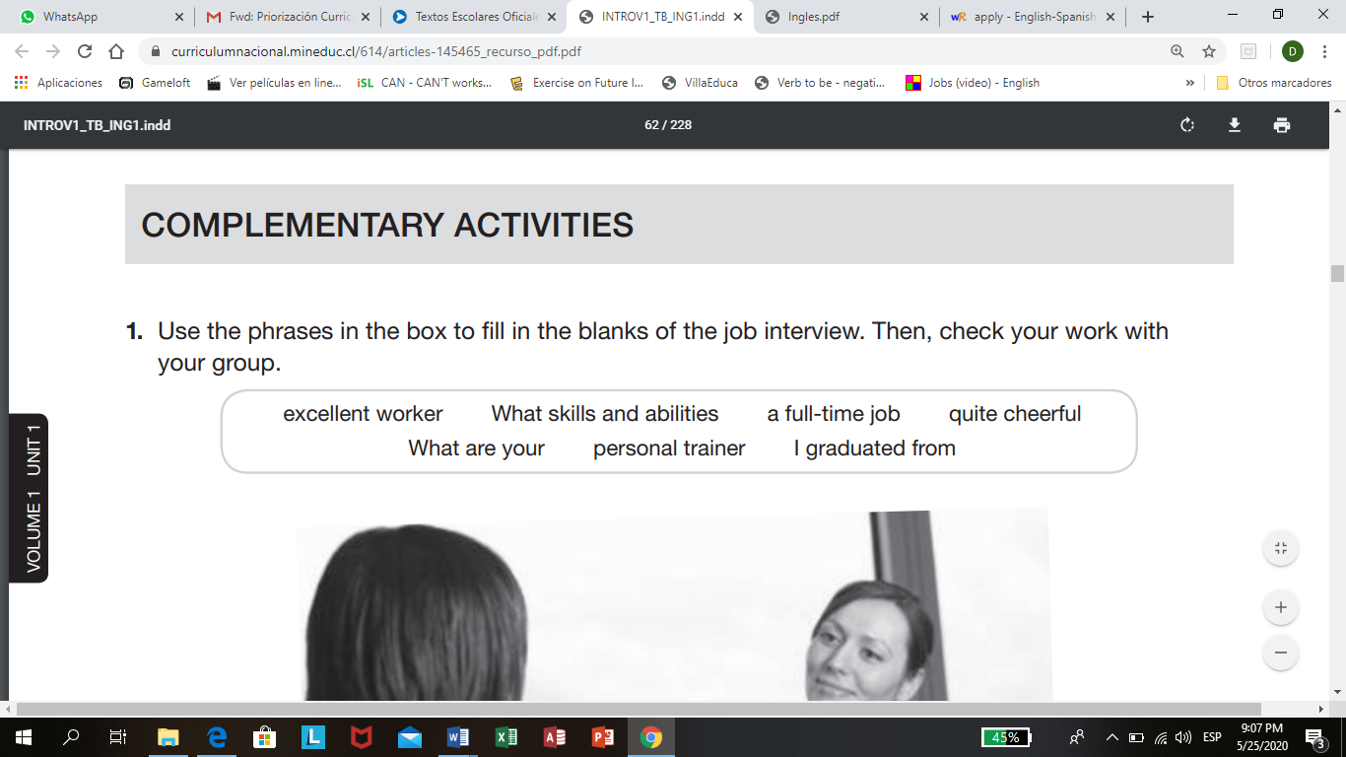Use the phrases in the box to fill in the blanks of the job interview.



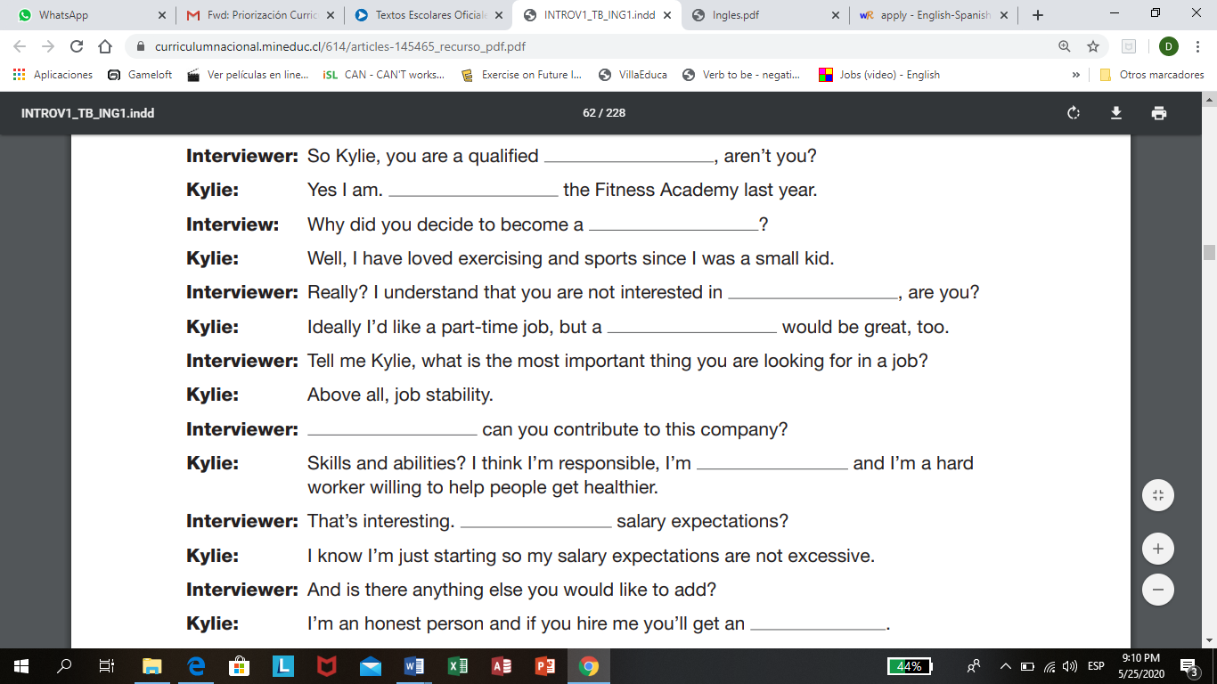

Find the meaning of the sentences below in Spanish.

Excellent worker: personal trainer:

Quite cheerful: skills and abilities: