|  |  |
| --- | --- |
| antorcha liceo | **Liceo República Argentina**  Coyhaique  English Worksheets  Teacher Dircia Ampuero |

English worksheet

Instructions:

You can complete the exercises on your copybook, take a picture and send me the photo to my email: [dircia.amp@gmail.com](mailto:dircia.amp@gmail.com) or complete the worksheet in the computer and send me the worksheet again to my email.

1. According to the description write the correct Job´s name.

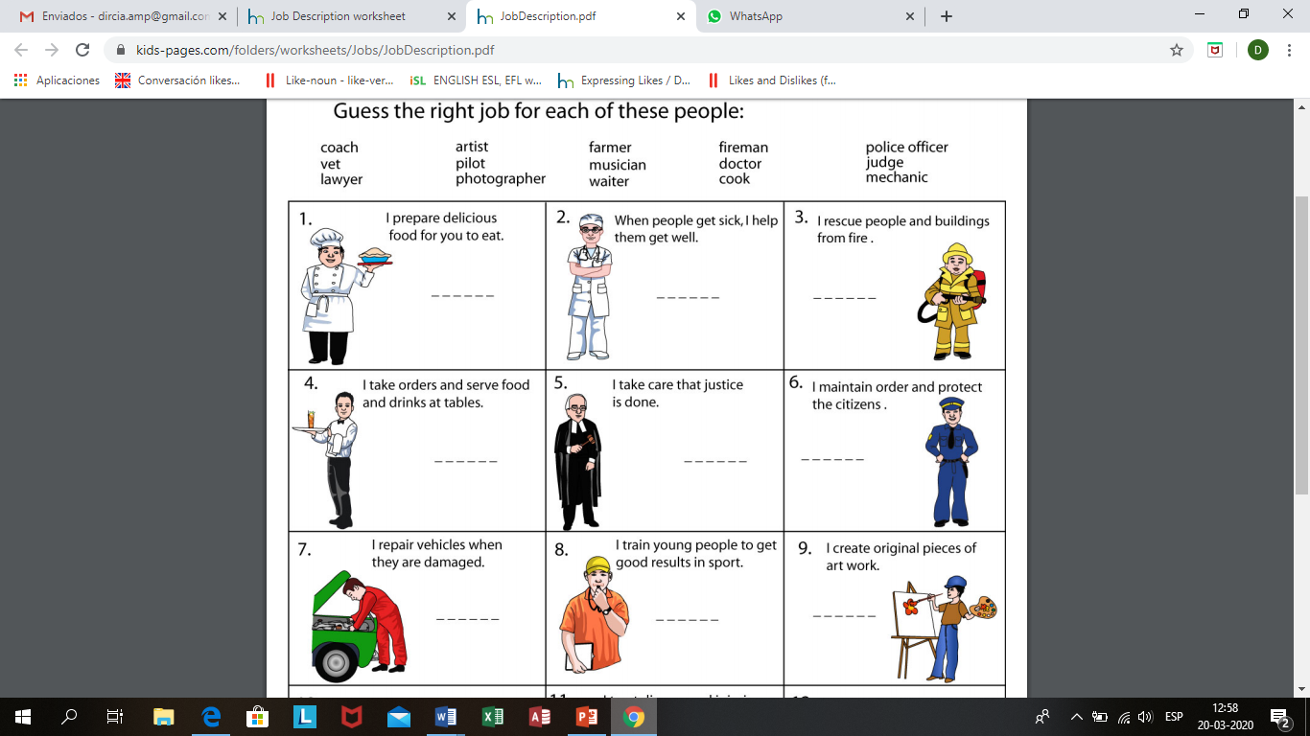

1. I prepare delicious food 2. I take care of people´s health

Who am I? …………… Who am I?................................



3. I rescue people and buildings from fire.

Who am I? ………………………

4. I take order and serve food 5. I repair cars, when they are

And drinks. Damaged.

Who am I? …………………………….. Who am I? ……………………………

6. I take care of animal´s health 7. I help to the doctor, to take care

Who am I? ………………………….. people´s health Who am I? …………………………

1. Put the correct number in the jobs list.

|  |
| --- |
| FARMER |
| WAITER |
| DANCER |
| REFEREE |
| JOURNALIST |
| DOCTOR |
| LAWYER |
| CLEANER |
| ORCHESTRA DIRECTOR |

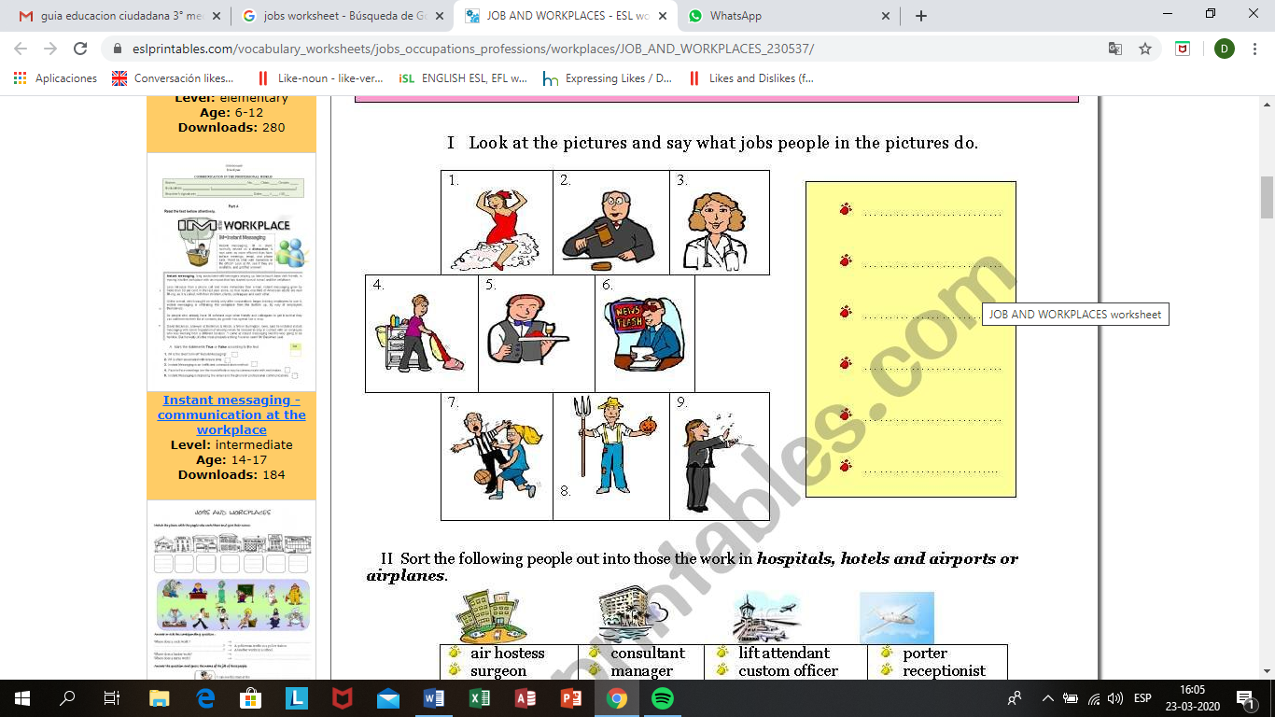

1. Read the short paragraph, and answer the true or false sentences and the questions.



My name is Jonhy Jhonson, I am 45 years old and I am a pilot. I work in American Airlines and I wake up early everyday so I don´t have any free time. I work from Monday to Friday and I rest on Saturday and Sunday. I like my job but I don´t see my family very often so I miss them.

Answer True ( T) or Falso (F).

………… Jonhy Jhonson wakes up early everyday.

………… He is a fireman.

………… He is 45 years old.

………… Jonhy Jhonson is single.

………… He works in American Airlines.

………… He works from Monday to Sunday.

Ansewer the question

1. What is Jonhy Johnson’s job? …………………………………….
2. How old is he? …………………………….
3. What is the name of his airline? ……………………….....
4. Does Johny see his family every day? ……………………………….