|  |  |
| --- | --- |
| antorcha liceo | **Liceo República Argentina**  Coyhaique  English Worksheets  Teacher Dircia Ampuero |

English worksheet

Full Name: …………………………………… Grade: ………………………

Instruction:

Complete the sentences in the worksheet and then send me an email, with the answers in color red or answer in your copybook and send me a photo, [**dircia.amp@gmail.com**](mailto:dircia.amp@gmail.com)

**Delivery date, April, Friday 3rd 2020.**

1. **Guess the correct job´s name, according to the description.**

I move people around. I wear a uniform

I drive a car. I work in a surgery

I charge a fare. I work in a hospital

I drive a taxi. I make sick people better

…………………………….. ………………………………..

I wear a uniform. I use markers

I am often a woman. I work in a school

I work in a hospital. I teach to students

I help a doctor. I give homework

…………………………….. …………………………………

I wear a uniform I wear a uniform

I often have a gun I drive a vehicle

I conduct traffic I pick up people

I catch thieves I drive a bus

…………………………….. ………………………………….

1. Answer the question about yourself.

* What job would you love to have in the future?

……………………………………………………………

* What do you think is the most boring job in the world?

………………………………………………………………….

* What do you think is the most dangerous job in the world?

………………………………………………………………….

1. Write these sentences under the corresponding picture.

-~~They work in a hospital.~~ - She meets people from different countries  
- They wear an uniform. - She speaks three languages.  
- She helps people. - They work on a computer  
- She sells things. - She works in a shop.  
- They help sick people. - She translates things.  
- She works at the United Nations. - They ask people questions.  
- They work in a newspaper office. - They work with doctors.  
- She looks after money. - They write a lot.



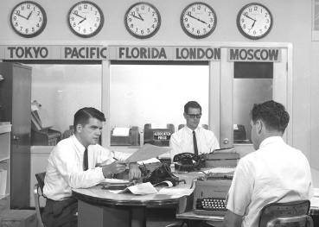

They are nurses They are journalists

……**They work in a hospital**…… ………………………………………

……………………………………… ……………………………………….

……………………………………… ……………………………………….

……………………………………… ……………………………………….



She is a shop assistant She is an interpreter

……………………………………… ………………………………………

……………………………………… ……………………………………….

……………………………………… ……………………………………….

………………………………………. ………………………………………..